**Deep Learning**

**Week 1-2-3: Feed-forward neural networks**

* **0. Overview:**

Data science is a combination of computer science, maths, and domain expertise on the subject that you study. This course is focused on maths and computer science.

**Statistical artificial intelligence**: We fit statistical models and large quantities of data to learn from data to make systems that can generalize to datasets outside the training data.

**Reinforcement language is when** you take actions in an environment that will affect you in the future.

* **1. Deep Learning:**

DL is a rebranding of the artificial neural networks name. Lacan has defined it as that it is deep learning if there is more than one step of a nonlinear feature transformation.

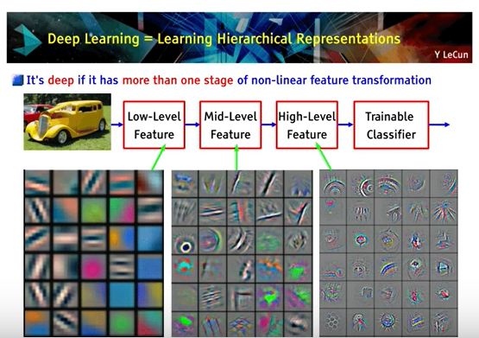

* **2.1 Feed-forward neural networks:**

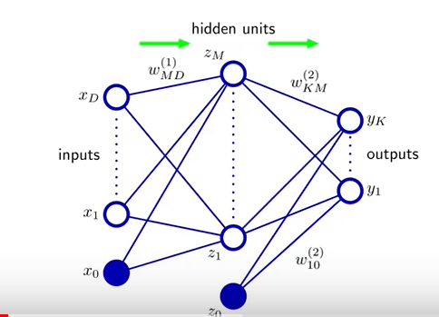In **supervised learning**, we have an input and an output and what we do in the neural network is that we train a conditional model, so given an input, the output is predicted.

Each of the **units Zm** in the hidden layers has a linear model. It takes all the inputs, and it takes a weight. Then is applied a non-linearity, a so-called activation function and then you repeat the process in the second layer with new weights and then you compute the output.

In each layer, you apply a non-linear transformation, but you can also apply the identity.

X0 is the bias term. It is used to shift the activation function. For example, being sigmoid the activation function, the result without bias can be:

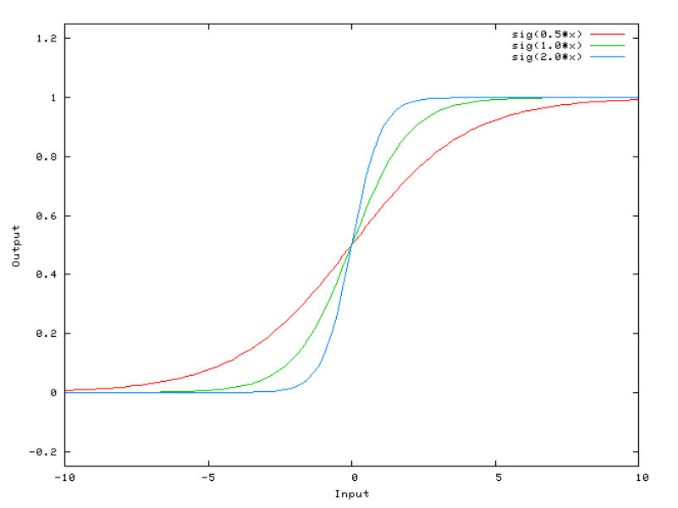

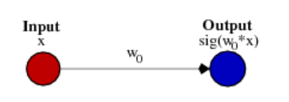

But when a bias term is added you can shift the activation function:

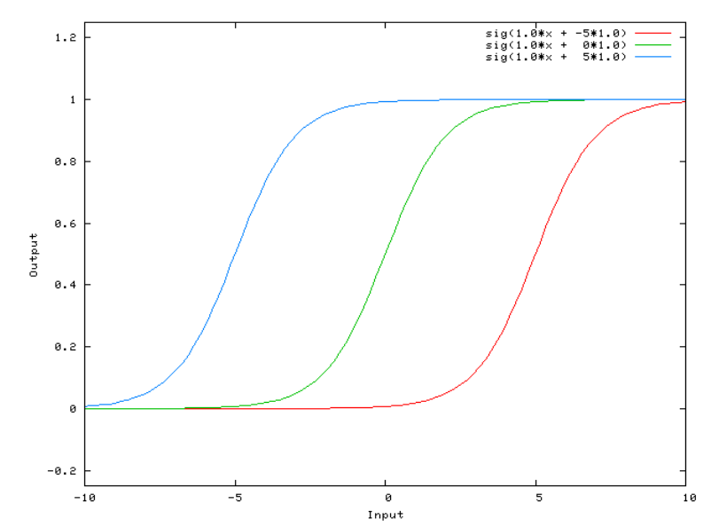

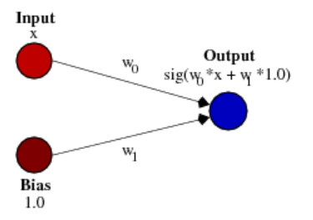

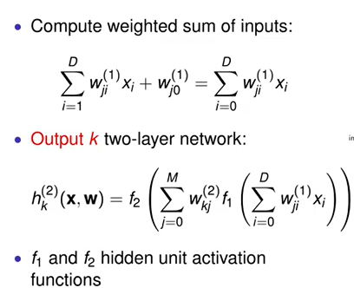

The first layer multiplies the weight by the input and then adds the bias term.

And the output of a 2 layers network

Non-linearity and training:

There are different options for these activations’ functions.

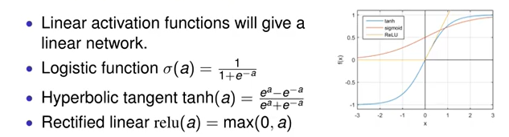

**Logistic function** gets a real-valued number and then it transforms between 0 and 1 and interpret it as a probability number. It is computationally expensive, causes vanishing gradient problem and not zero-centred. This method is generally used for binary classification problems.

**Softmax** is a more generalised form of the sigmoid. It is used in **multi-class classification problems**. Like sigmoid, it produces values in the range of 0–1 therefore it is used as the final layer in classification models.

**Hyperbolic tangent** (blue) was very popular but when you do gradient descent-based learning you can get the learning process stuck even if your output is incorrect. Compared to sigmoid, it solves just one problem of being zero-centred.

**Rectified linear,** in the code, is fast and it has better convergence properties.It is easy to compute and does not saturate and does not cause the Vanishing Gradient Problem. It has just one issue of not being zero centred. Since the output is zero for all negative inputs. It causes some nodes to completely die and not learn anything.

**\*\*\* Research: Desirable features of an activation function\*\*\***

**\*Vanish gradient problem:** Certain activations functions, like sigmoid, squishes a large input space into a small input space between 0 and 1.

When the inputs of the sigmoid function become larger or smaller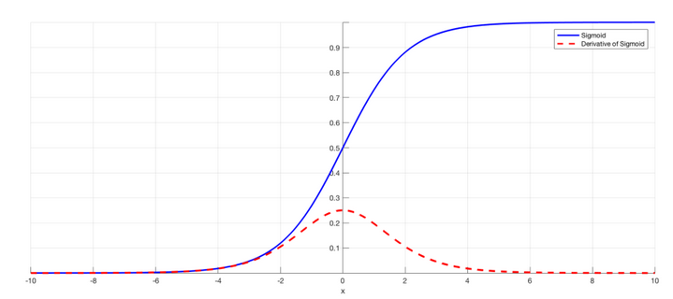, the derivative becomes close to zero.

Working with only a few layers is not important, but when more layers are added it can cause the gradient to be too small for training to work effectively. A small gradient means that the weights and biases of the initial layers will not be updated effectively with each training session.

Solutions:

* **Other activation functions**, such as ReLU, which doesn’t cause a small derivative.
* **Residual networks** are another solution, as they provide residual connections straight to earlier layers.
* Finally**, batch normalization** layers can also resolve the issue. Reduces this problem by simply normalizing the input so |x| doesn’t reach the outer edges of the sigmoid function.

**\*Zero-Centered:** The output of the activation function should be symmetrical at zero so that the gradients do not shift in a particular direction.

* **2.2 Feed-forward neural networks:**

**Supervised learning**: We have a training set of n examples, so which is a pair of inputs and the associated target value, which is called labelled training. In **unsupervised learning,** we only would have X (input).

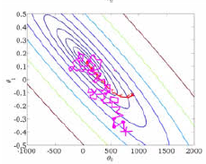

Conditionals models are trained to minimize the error. So, a **cost function** is defined to minimize that by **stochastic gradient** **descent**.

**\*\*\* SGD** randomly picks one data point from the whole data set at each iteration to reduce the computations enormously. It is also common to sample a small number of data points instead of just one point at each step and that is called **“mini-batch” gradient descent**. Mini batch tries to strike a balance between the goodness of gradient descent and the speed of SGD. **\*\*\***

**Overfitting:** when you fit well to the training situation, but you see new examples not making good predictions.

Example network:

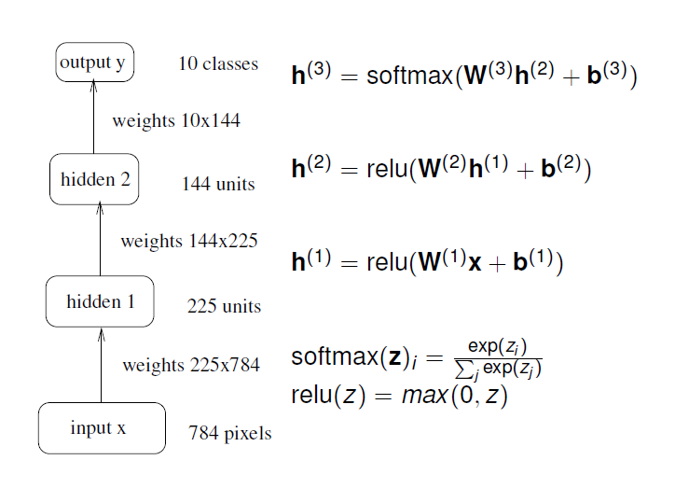X is a long vector unfolding the image, 28*28.

We have 2 **hidden layers**, each one with its own **units**, and they are both **relu** activation functions.

Finally, **SoftMax** is used because we want a classification system and it has the property that can interpret the output as probabilities, due to the function definition.

Also, in each layer is defined a vector with intercept term (**bias**).

SoftMax:

Has 2 properties:

* + Because of the exponential function it means that **the output** for each dimension is **always non-negative**.
  + Because of the denominator the **output will always sum to one** (Probability).

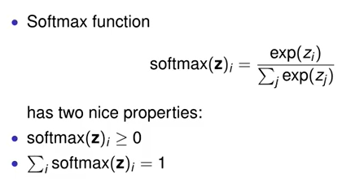 Very nice to construct a network which is a **probabilistic classifier**.

On activations functions:

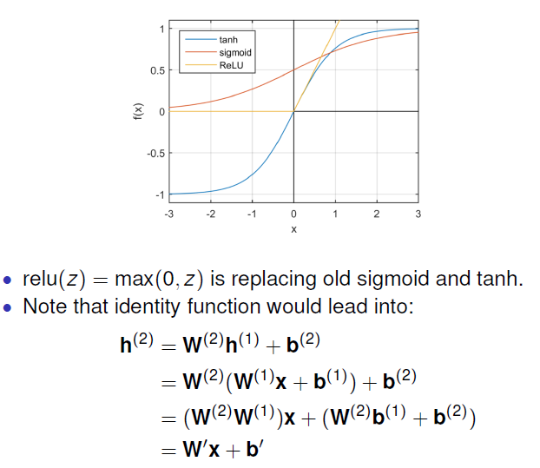We don’t use linear activation functions. Replacing 2 relus with linear models and calculating at the end it says that h(2) is just a linear function so that means that the feature transformation we make here can only be linear. That is why we should use non-linear activation functions.

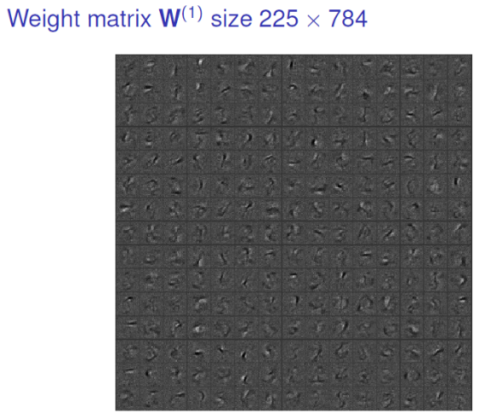

**Weight matrix W(1):** the second dimension of the weight matrix of the first layer has the dimension of the input. And the first dimension are the weights for each specific unit.

After training it the network has pick kind of features that corresponds to generic tools. In that way can extract features of sub-parts.

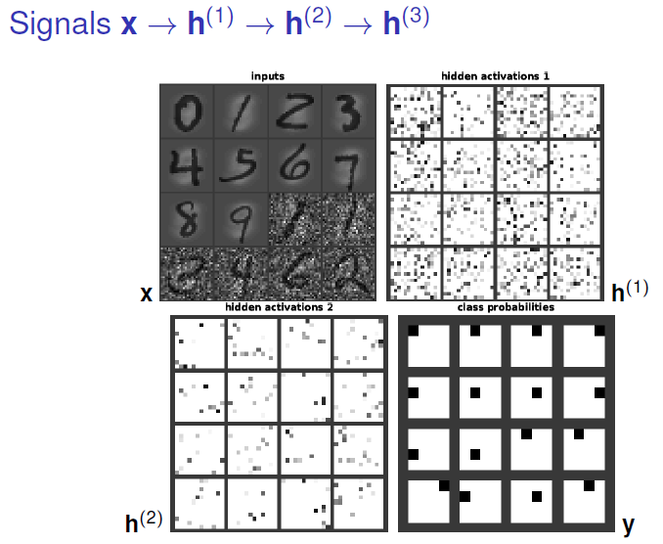

It can be seen for example that, the ones that appear in the input has similarities in the second hidden layer, because those has been passed through the same activation functions. That is how numbers can be predicted.

On sparsity:

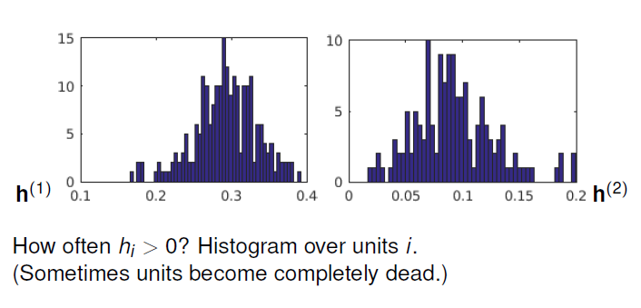We can see the output of the first and second hidden layers for a specific example. What is non showed are all the outputs that are zero.

* **3. Neural network training: Backpropagation**

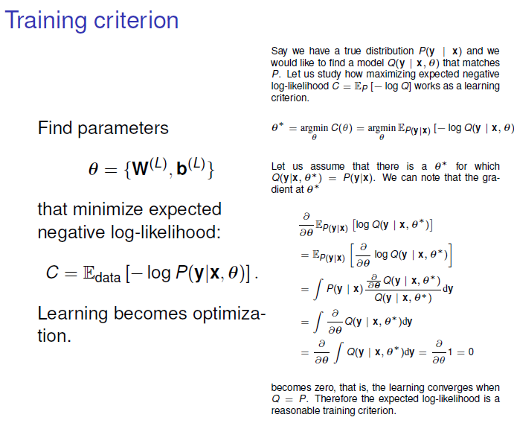

**Why negative log-likelihood is used?** The derivative of a positive function is 0 exactly where the derivative of its logarithm is 0, and the log of that function has a much simpler derivative.

**\*\*\*Explanation about negative log-likelihood\*\*\***

<https://goodboychan.github.io/python/coursera/tensorflow_probability/icl/2021/08/19/01-Maximum-likelihood-estimation.html#google_vignette>

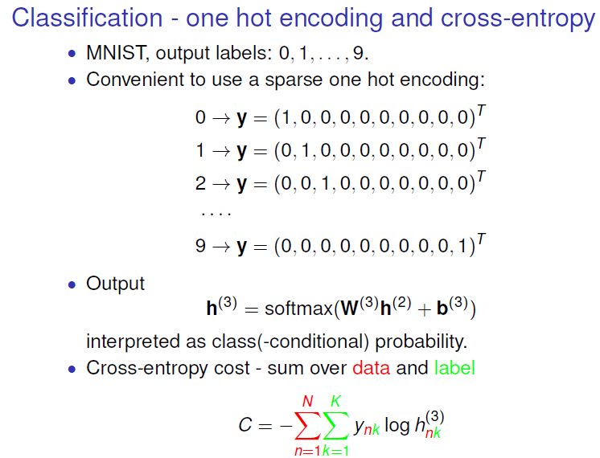

**One hot encoding** is the idea in which we take our class and make that into a sparse vector which has the same dimensionality as the number of classes.

The output is the softmax, which means that each term represents a probability.

In C we have - sign because we want to transform a maximization problem into a minimization problem. Being n the number of examples, and k the number of classes.

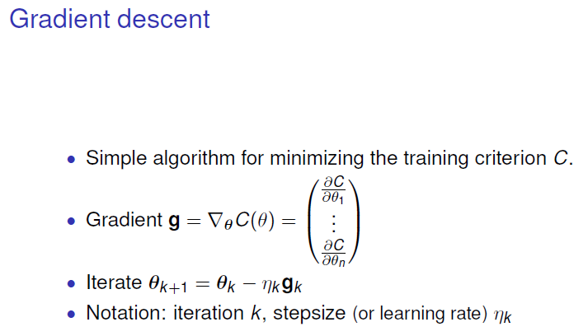We use **Gradient descent-based learning**, which means that we have some **training criterion**, for example log likelihood, and then we **compute the gradient** (taking the derivative of the cost function).

And the basic operation is to take a small step opposite the gradient, making down moves.

We have a **learning rate** which might depend on which step we have taken.

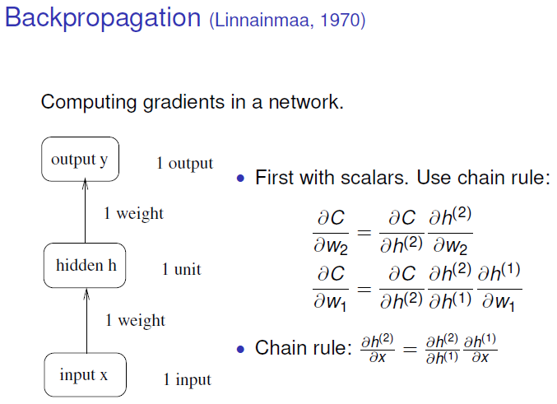

Simplest non-trivial network: linear outputs with 1 HL and 1 unit.

The cost function will depend on the weights of 1st and 2nd layers.

Taking derivatives, we can see that the cost function depends only implicitly on the weights, and explicitly on the activation of the second layer.

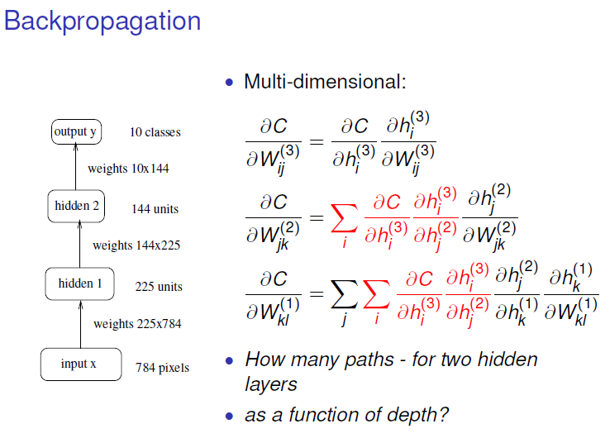When having more layers there are reused computations through the layers, so if we store these computations, we will simplify it.

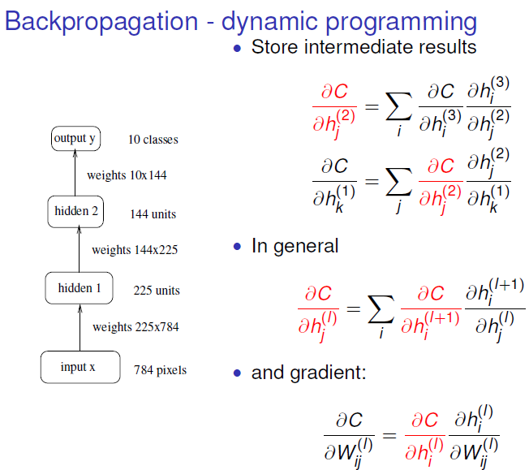**In the backpropagation algorithm,** we say that the derivatives of the cost function on one layer are defined in terms of the derivatives of the activations on the next layer.

Forward propagation is when we propagate the inputs to the outputs and calculate the cost.

When having done backpropagation in the middle equation we can compute the actual gradient simply by the last of the rule.

The important thing here is that we must store a lot of things in memory, and this is usually a problem if we have like recurrent NN which can be a little bit memory-consuming.

* **4. Neural network training: Optimisation**

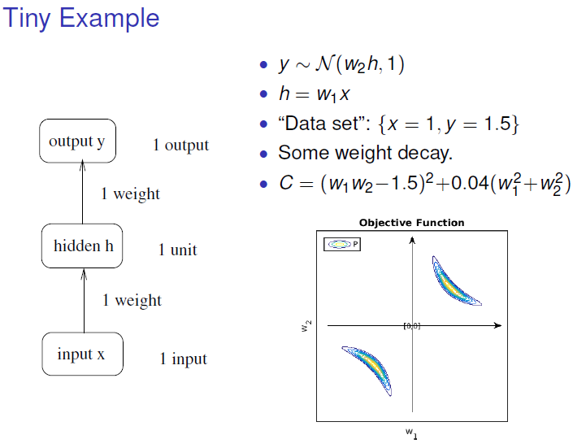We have one training point and a network with a linear output unit. We set the input to 1 and the target to 1.5.

The output of the network is simply w1 times w2. Then we have the square error looking at the difference of this w1 w2 to 1.5, and a penalty is added to the square length of the weights. This is the plot.

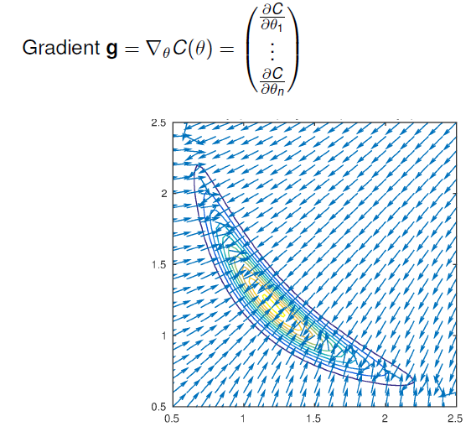

We only have 2 params. The gradients are always pointing to the minimum

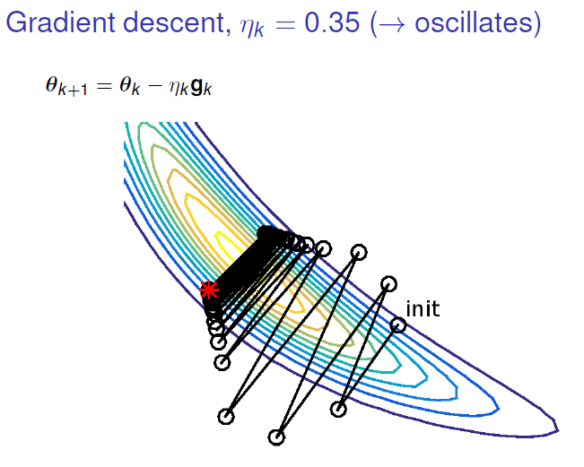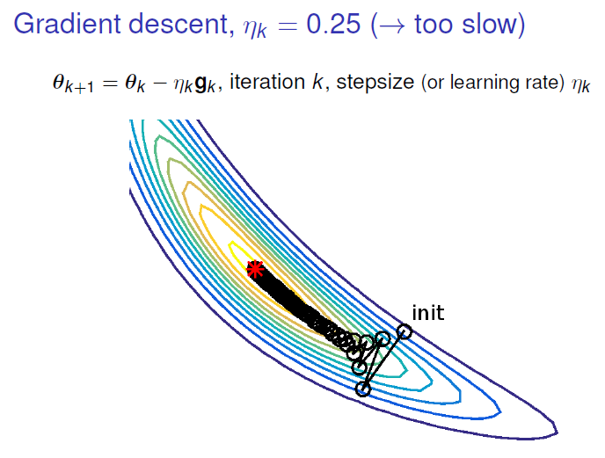

Selecting **n=0.25** we can see small steps that take some time to get the minimum wasting a lot of time, we used to avoid this kind of spectra.

Increasing step size, have a tendency that goes far of the minimum overshooting our target.

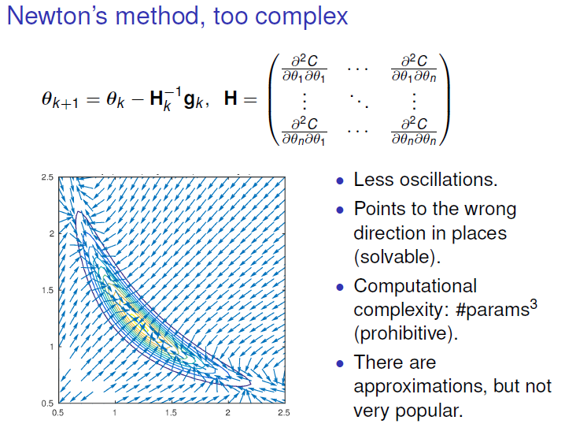Using the curvature, by the second derivative (Hessian), this method takes this into account.

In Newton Rapson rule we can replace the learning rate by the inverse of this H matrix. This works very well when we are closer to a quadratic minimum. But, as can be seen in the corner, gradient points in the opposite direction.

This method is very computationally intensive because the inverse matrix must be calculated. But it can give you a good intuition about which step size to use.

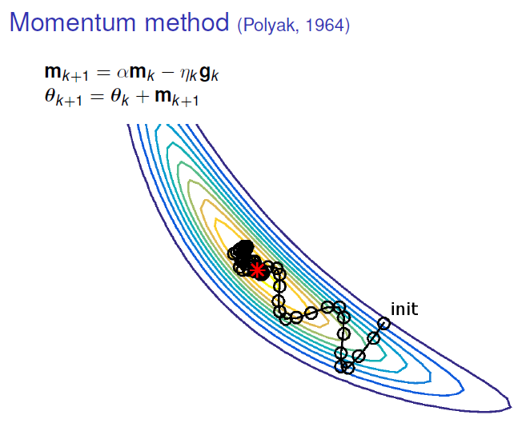

One thing to avoid the oscillatory behaviour is to **remember where you went in the previous step** **(Momentum method).**

This **m parameter** remembers where the gradients were in the previous step and then you only modify this by having this **alpha** in front which is below one so you can slowly forget your old gradients and then do new steps.

This has a smoother behaviour.

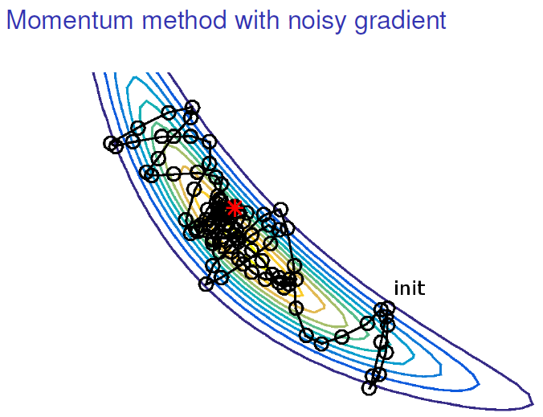

A noisy gradient is something that we get when we have mini-batch learning. It looks like is not a really good idea but with large systems is very nice.

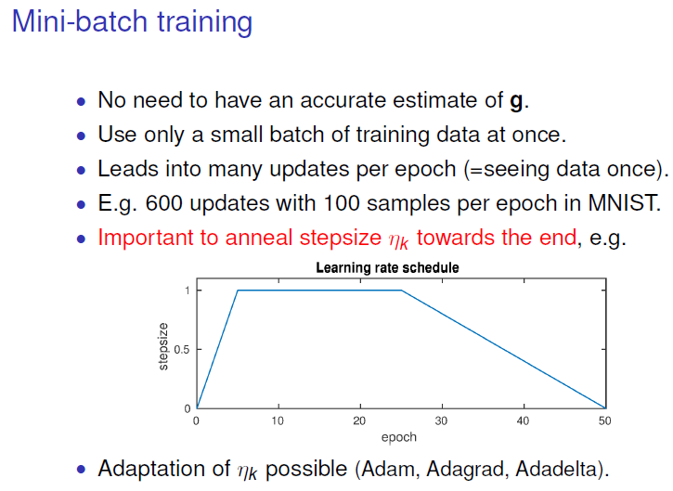**Mini batch:** We calculate the gradient on not the whole data but on a subset of data.

This means that maybe in the beginning you can be so far (initialize with some random parameter setting), so you need a few data that give you a general sense of where you want to go.

Secondly, having a stochastic gradient introduces some noise that helps you to get out of local minima.

Third thing is that, if you have a large dataset and you use your GPU you will not be able to store all data in your memory and therefore it’s nice only to have to store some of the subsets of the data.

We need to change step size through learning.

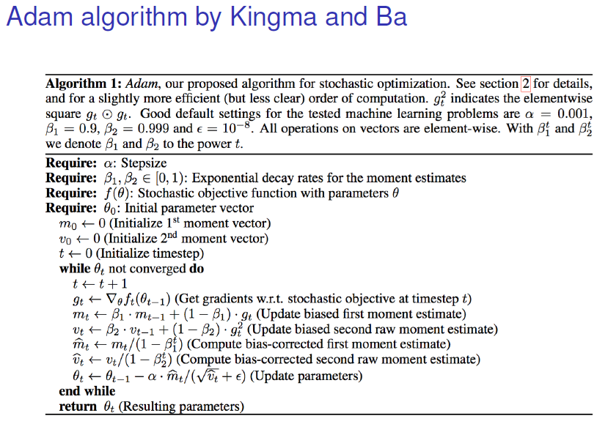

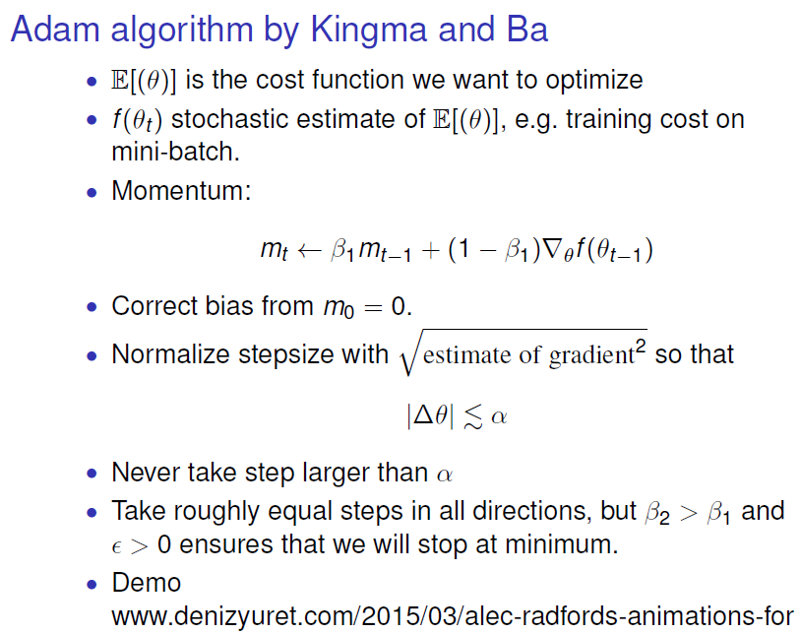

The step that we take is never going to be larger than alpha. That is a way to kind of control that in all directions we have the same step size, and we know how big it is and it is easy to know more or less how big the steps need to be.

Fixed step size makes the training stop the convergence at some point. These types of algorithms try to avoid these problems.

# Week 1-2-3: Convolutional neural networks

* **1. Introduction to CNNs:**

**CNNs** are used for image classification. The idea in CNNs is to do a lot of **weight sharing** in a way that we can extract features from an image in different locations in the image. So, the same kind of weights are applied in different parts of the input. We are going to apply the same “**filter**” for all areas of the image.

We apply a filter (3x3 weigths) to the image and produce an output image. This is done starting in one corner with the filter and then we do the **element-wise product between grey values in the image and then the values of the weights in the filter**. If we do that with this type of filter (weights example) it will pick up edges that are 45 degrees.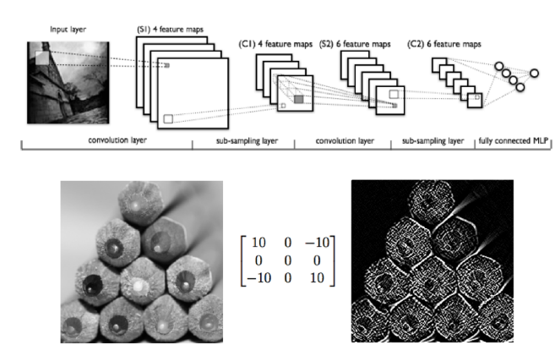

These weights are learned from data. Another operation that we have in CNNs is called **pooling**. The general idea is that we have these filter layers, we learn many different filters usually all of them have the same size for a specific layer, and then we have pooling layers and then we repeat it again.

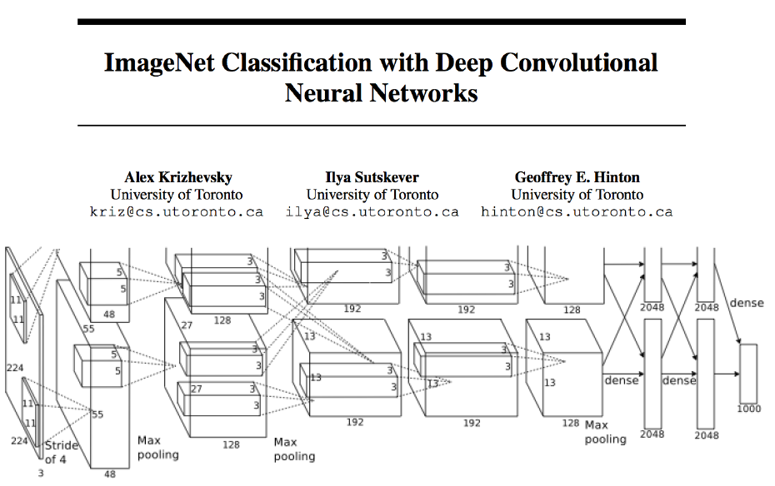The most famous deep learning paper. Numbers indicate dimensions of each particle filter that is being applied.

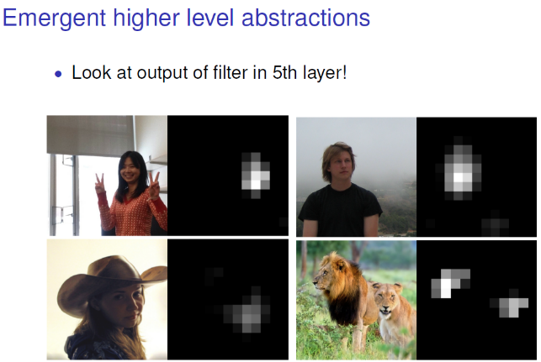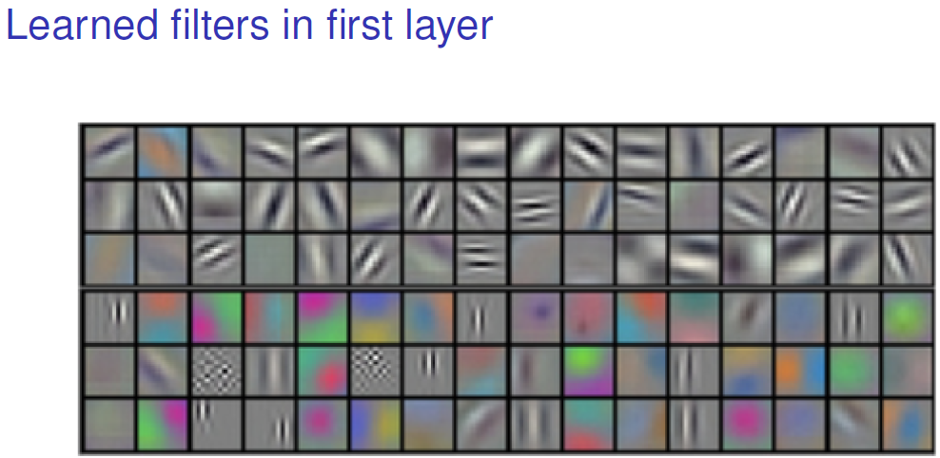

* **CNNs the details:**

**\*\*\*Explanation of dimensions in CNNS\*\*\***

[**https://towardsdatascience.com/a-comprehensible-explanation-of-the-dimensions-in-cnns-841dba49df5e**](https://towardsdatascience.com/a-comprehensible-explanation-of-the-dimensions-in-cnns-841dba49df5e)

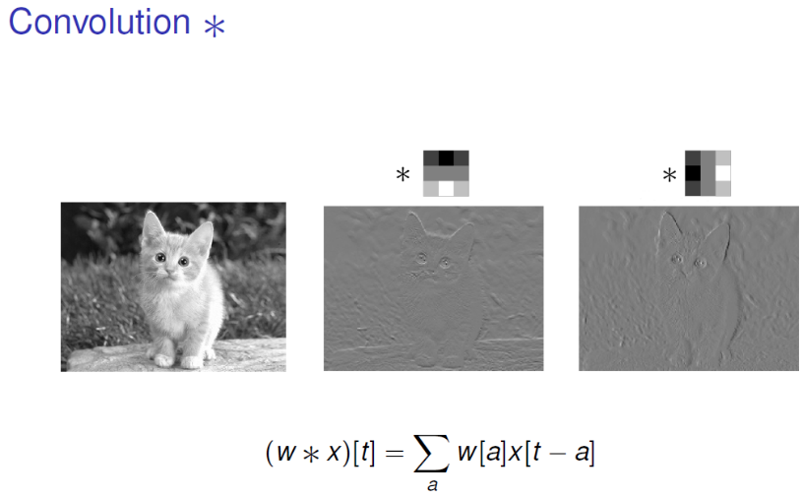Applying 3x3 greyscale 2D convolution is possible to detect edges in different orientations.

Mathematically, we sum over all the elements in the matrix multiplied by weights.

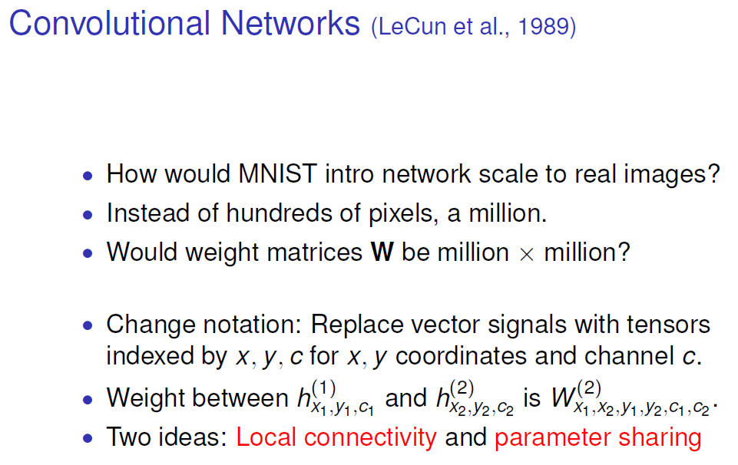

MNIST dataset is nice because we have 28x28 images. Imagine we have 1000x1000 images then we really need a lot of weights.

The main things with CNNs are that we have local connectivity and parameter sharing.

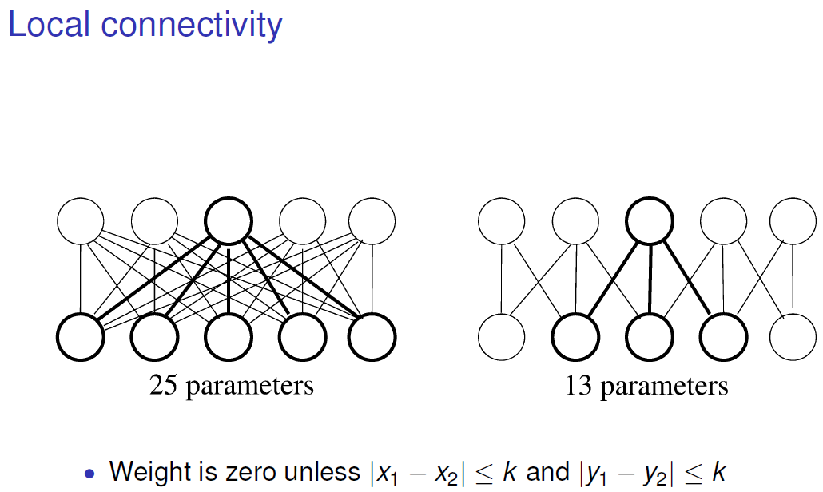

1D input with 5 pixels connected with 5 units in next layer. If they are connected all in all we have 25 parameters.

**Local connectivity: First restriction** to have less parameters by **only connecting the next layer weights to the kind of the neighbouring weights** as it’s shown in the 2nd image reducing number of params.

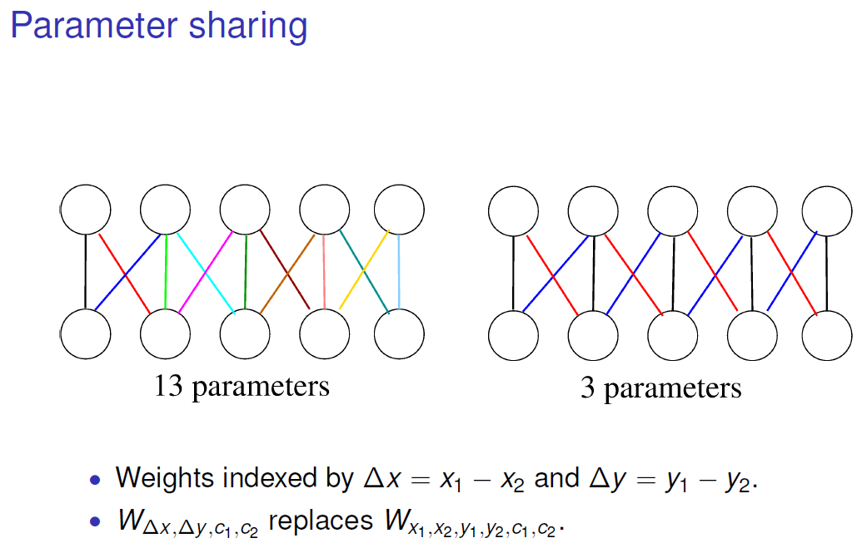We can make a **parameter sharing** as shown by these colours, so we can say we will use **same weights in kind of the connections in the same direction** having only 3 parameters.

If you think in each hidden unit extracting some feature from the original image, then we can extract this feature in all places of the image with these 3 params.

So, if we are looking for edges in a specific direction, with these 3 weights can extract the kind of pattern in the input.

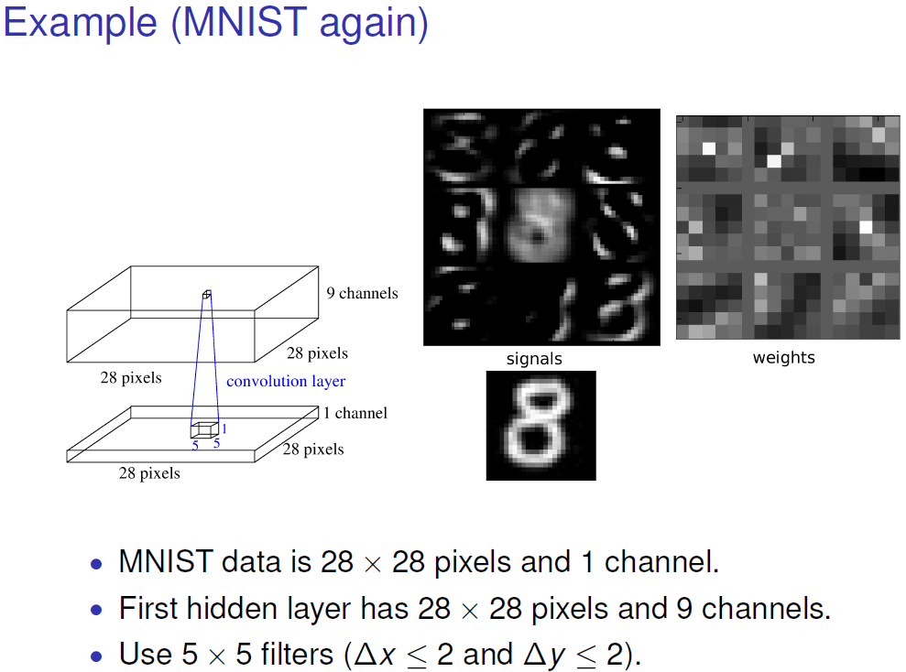Boxes indicate dimensions of our inputs and our filter images. The convolutional filter chosen is 5x5x1 (if we had a RGB image, the filter would be 5x5x3).

We choose to have 9 of these filters. Applying **zero padding**, which means adding zeros in the edge of the image to preserve the size of the input image, the output of the filters would be 28x28x9 (we call 9 channels).

We can see that each of the filter has extracted some features from the original 8.

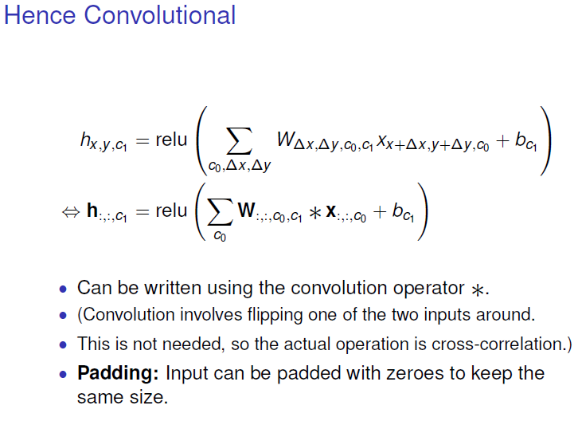

We sum over the channels in the input layer

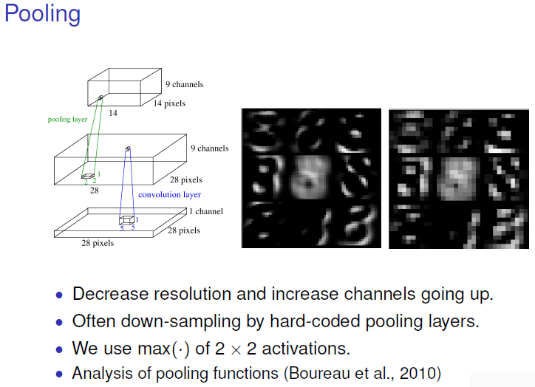 Pooling is an operation that makes the output smaller.

We can use different types of pooling. For example, **average pooling means** that the output of the pooling layer is the average of the elements. Also, we can use a **max pooling meaning** we look at the maximum activation in this 2x2 area and then we simply pass only the max.

The reason we use pooling is that we want to reduce the computation in the subsequent layers so we will implement a kind of approximate local translational invariance.

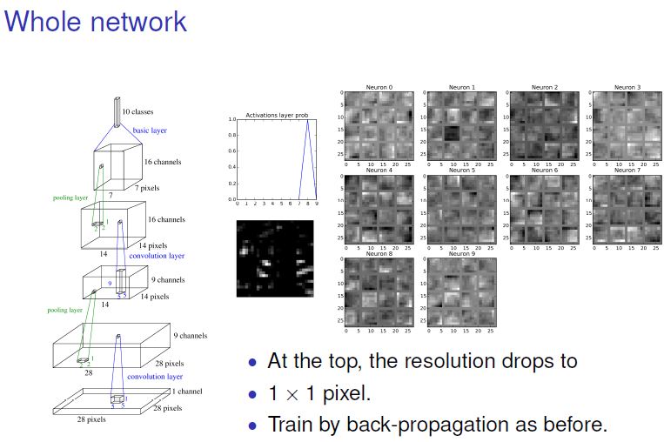

From the bottom to the top. A convolutional layer is applied with 9 filters. Then, we have a 2x2 pooling so we have only half the number of pixels with same channels. Then, a convolutional layer is applied. Another 2x2 pooling layer. And finally, we can take all these 7x7x16 values that we make into a long vector that we feed into a feed forward NN.

We train all this by back-propagation as before. In the output we can see a big probability of the class 8.

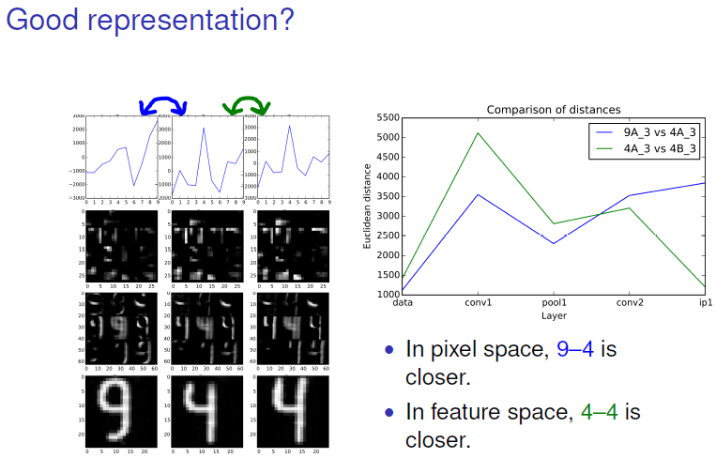

The closer we get to the output, the more we hope that the features we have will look alike if we push images from the same class.

If we look at pixel wise distance at the beginning distance between 9-4 is smaller than the one between 4-4. But when we get to the 2nd convolutional layer, we get more accurate.

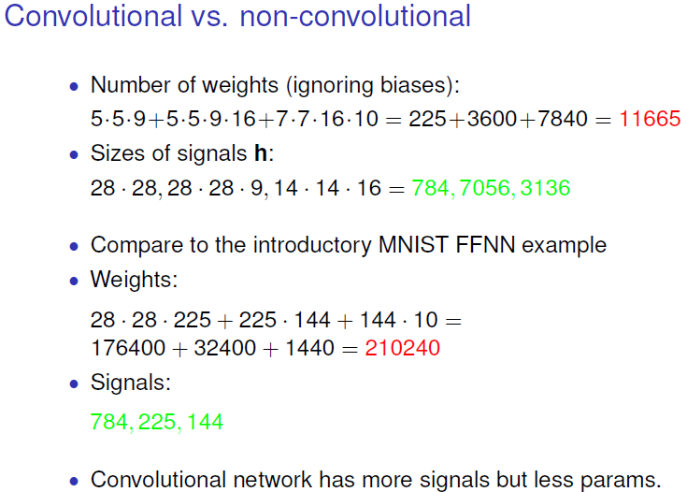

Another important point about weight sharing is that we can do some counting both on the number of weights in the network, but also the number of features that we extract in different layers.

So, in 1st layer we had 5x5x9 filters, so we had 5·5·9 parameters. And the same for next layers. For the 2nd layer

we still have 5x5x9 and we have 16 of those filters.

So, finally we have **11665 parameters which are quite low**.

Compared to FFNN weights are less now than before, so that means that with FFNN we could risk overfitting with this type of NN.

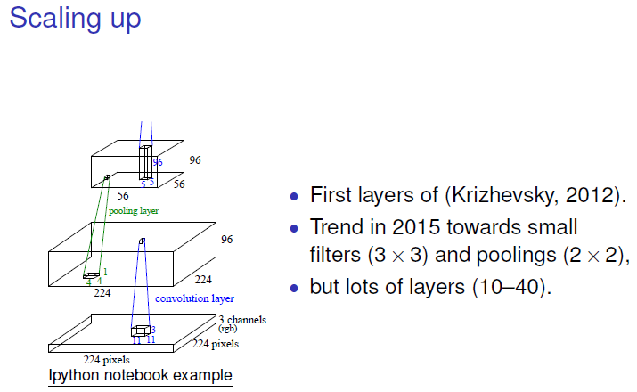Trend is that a lot of people use smaller pools and lot of layers (150 Microsoft).

* **2. Res-, Dense- and Wave Nets:**

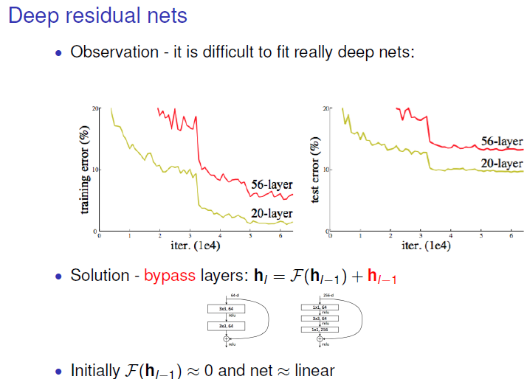

When having more layers in a NN is more difficult to train it because when doing backpropagation, you can get stuck at some suboptimal solution.

What is proposed in **resnet** is to sum the output of the L-1 layer to the output of the L layer. If initially our F is close to 0 our NN is close to implementing a linear network, what means that we can start learning more linear features and then slowly we can make F different from 0 and then turn on the feature maps that we need.

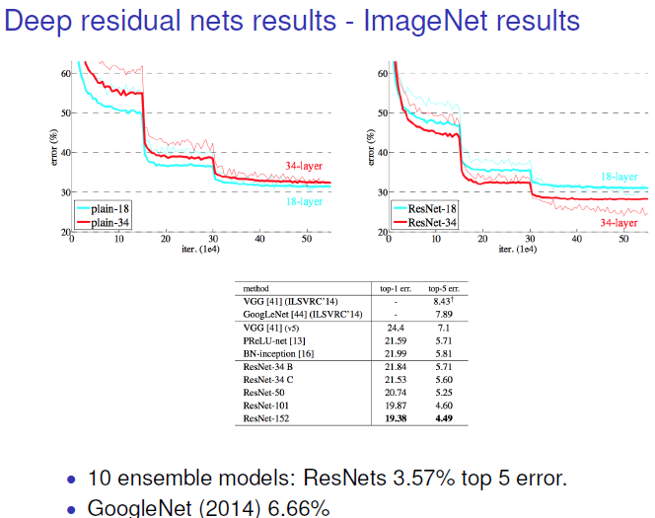 Left plot is a regular NN and the right one a resnet. We can see how resnet with more layers improve its accuracy.

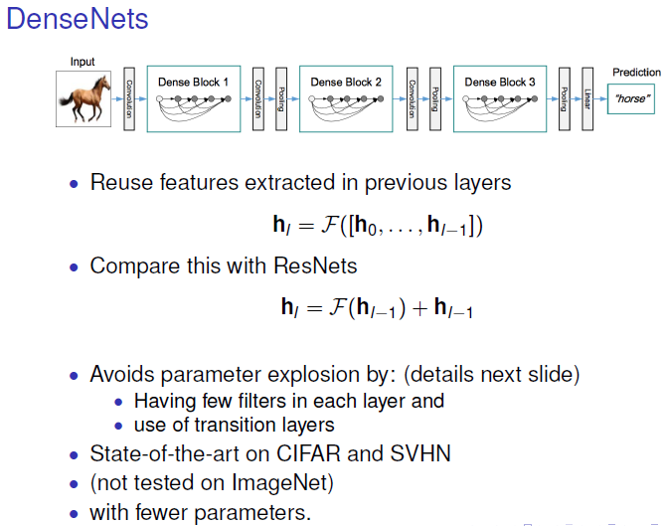

**DenseNets** uses the output of previous layers to compute the output for the actual layer.

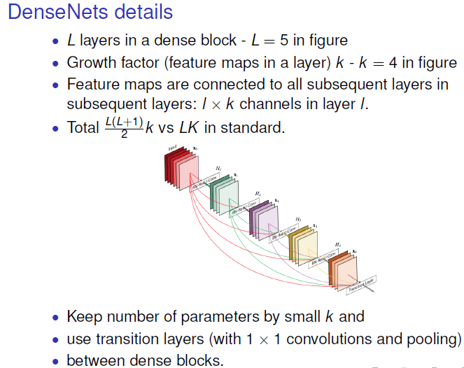

* **3. New activation functions**

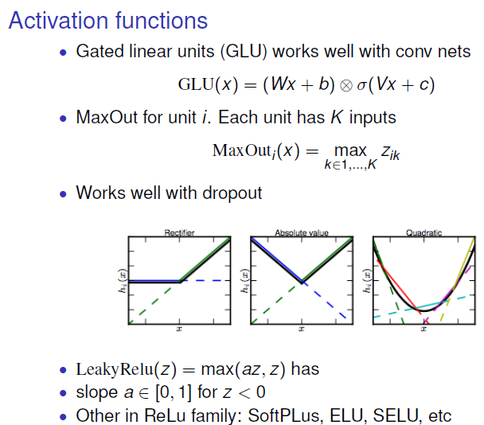**GLU**: has 2 linear models. The 1st is applied only to the input, and the 2nd one is applied to the input and a logistic function is applied.

**MaxOut**: Each hidden unit is connected to K inputs.

**Leaky Relu:** you allow a slope in the negative side.

* **4. Image segmentation**

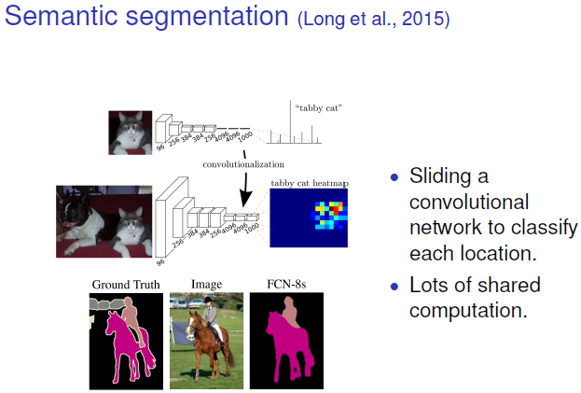You take an image, and you want to classify each of the pixels.

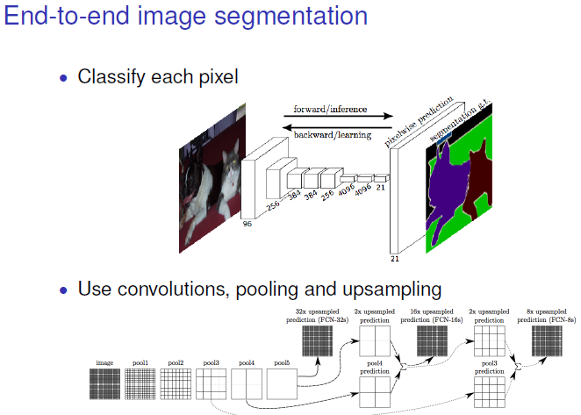First you go from the large image to a representation that has fewer pixels but more channels, combining local and non-local information to perform the segmentation. Then you must go from the low-resolution image with many channels as to the original resolution to classify objects in the image.

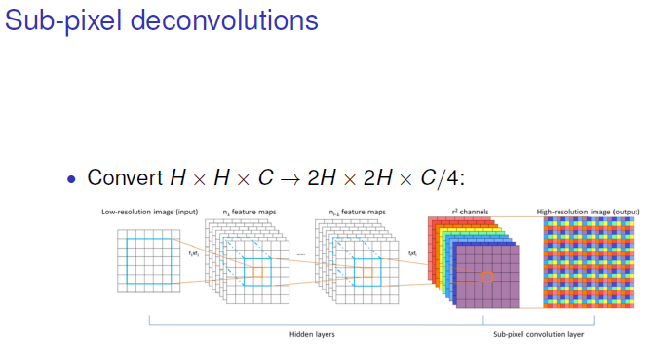In last layer, the one with the low-resolution image, we want to get the original size. So, one method is to multiply the size x2 and divide the channels by 4. Getting a larger image.

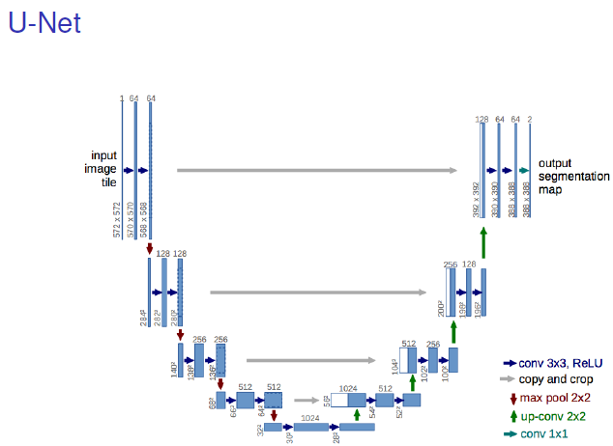

Used in modern image segmentation. The idea is that you want to perform something that use non-local information, going down to low resolution images after conv and pooling layers, but for having a fine-tuned segmentation you also need information from the original high-resolution image.

High- and low-resolution information is combined.

**Week 5: Transformers and recurrent neural networks**

* 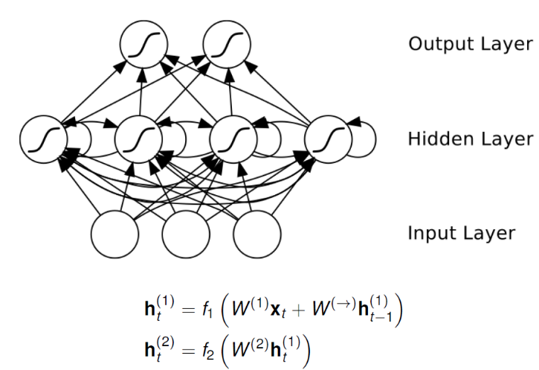**1. RNN**

The only addition that we make compared to the standard FFNN is that we have connections over time.

The **activation function** of the first hidden layer consists of a **term depending on the input** and then we also have an additional term that is a **connection that runs over time** (delayed contribution).

In principle, we can accumulate information in time for as long as we want.

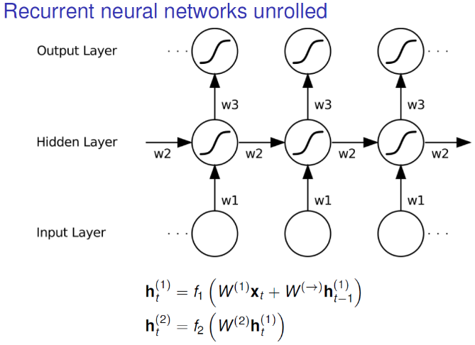In one column for each time step, you can see the weight sharing.

Vertical arrows are instantaneous, they send signals immediately. But lateral connections are delayed one time step

Each column is one FFNN

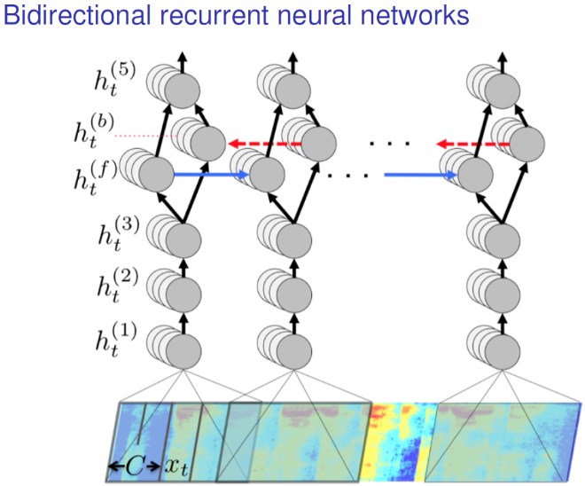The way in which sound is represented here is a spectrogram (frequency content for different frequency bands) and on the x axis the time going on.

First layers: CNNs and then we have forward layers (CNN or FC) and then we have signal running forward in time and signal running backward in time. That is because the interpretation of what is going on at the beginning of the sentence is affected by the end of the sentence, integrating information from the past and the future.

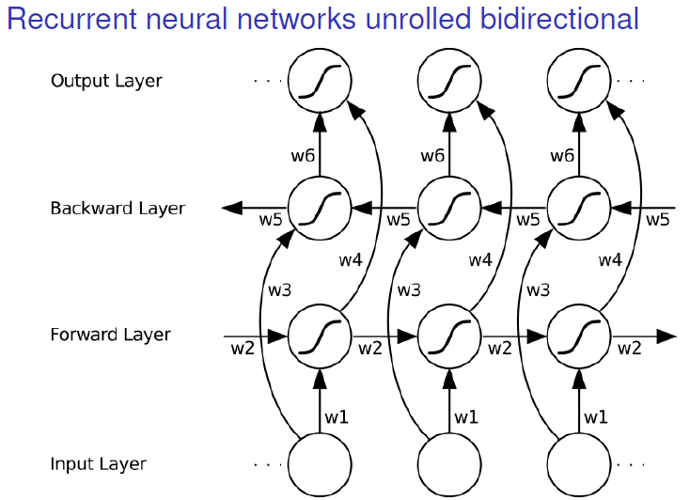

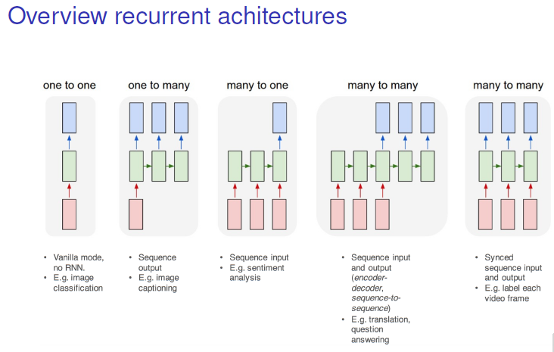

* **2. RNN training:**

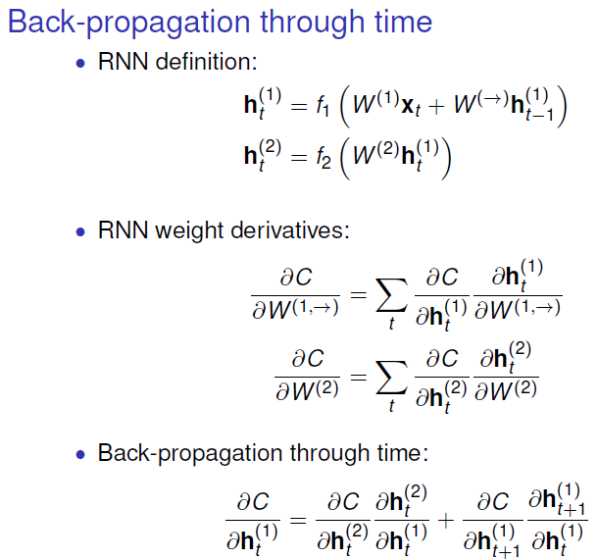We have 3 different types of weights: w1, w2, and then weights from the propagation across time.

When **doing back-propagation** through time we have the first term as in a FFNN, but in the **second term the cost function** **depends** also on the **activation of** the network **in the future**, and the future activation depends also on the activation at time now (because our signal is forward in time).

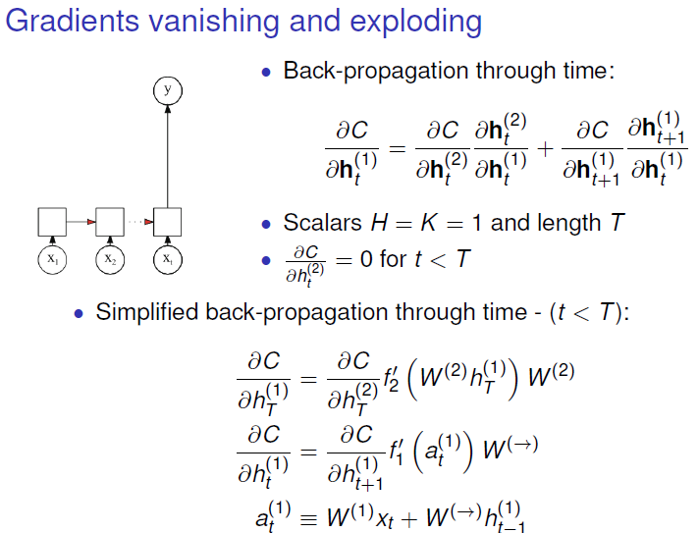A problem in deep learning is vanishing and exploding gradients.

This network has only 1 input, 1 hidden unit, and a sequence length T. Cost function only depends on the last time-step.

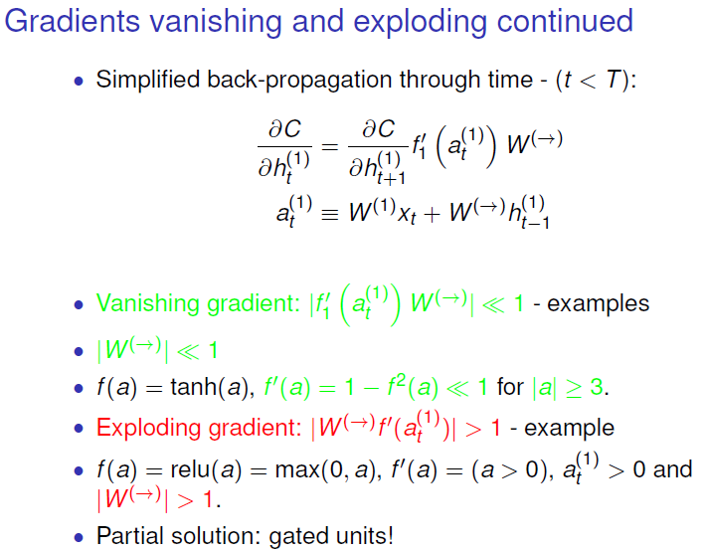 **Vanishing** is the most frequently occurrent situation, and this can happen if the factor that we multiply in our recursion becomes numerically very small (if the **weights** over time are very small **close to 0**, or if the derivative of the **activation** function becomes **small**).

For example, with **tanh (vanishing)** if the input is very large plus minus, then the derivative becomes very close to 0.

If our activation at one time instant is very large, it means that the gradients back in time are simply killed.

If we check **RELU (explode)**, derivative is 1 if argument is >0 what means that with having positive arguments to the activation function, and our weights forward in time are larger than 1, then we have a gradient that becomes larger. This effect with a lot of steps we will have a very very large number.

A partial solution about retaining gradients are **gated units** in RNN.

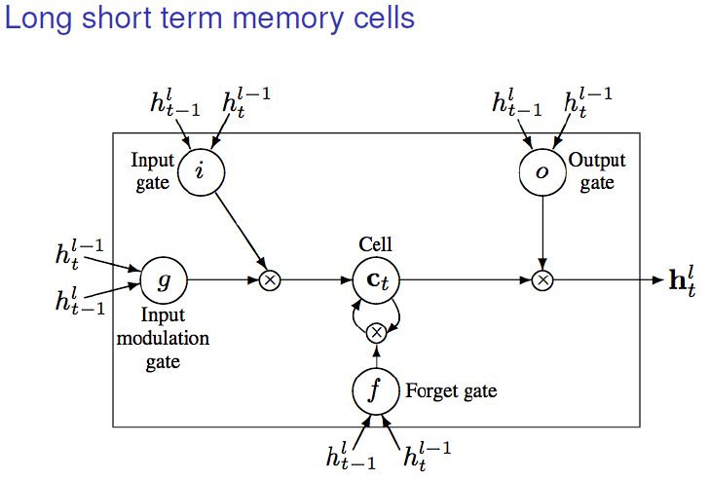

The main point is like a memory block in a computer which can either be overwritten or it can retain its value to the next step and when we need it, we can write it out and update our hidden state.

If the **forget gate** is set to on, then we will erase the content of the cells. Cells are just scalar values that we have defined at each time step. If it is not set, then we will keep values through time steps.

**Input modulation gate** decides what is coming in, and **input gate** decide whether what we want to put in there should be allowed to go in and then partially overwrite the current value of the cell. **Output gate** decides whether we should write the content of the cell to the hidden state.

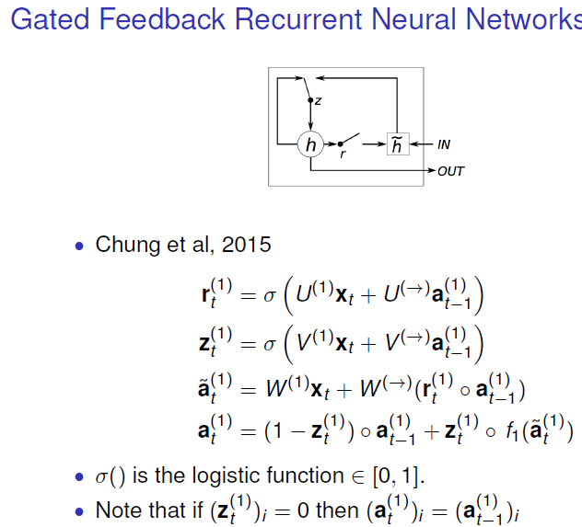We have sigma, which is the logistic function applied to the gated functions (r and z).

A is used to denote the input to the activation function. When z is 0 then you retain the value from the previous time step, and if it is 1 you update the value with the input data from that time and gated value from the previous time step.

* **3. DL for biological sequence analysis:**

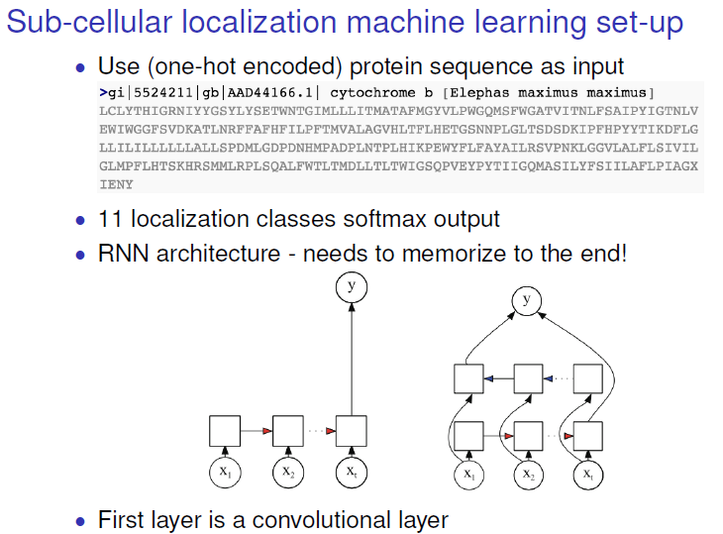We want to take the protein sequence and we want to predict in which compartment in the cell this protein sequence will end up. With data from experiments on where specific proteins end up, we can extract the rules of the cell use to decide where to locate proteins.

Inputs: Protein sequences, usually 20 letters, and 11 classes.

For example, we can use the **forward architecture**, the problem with that is if this signal which we believe is at the beginning of the sequence is **a bad architecture** to use because it will have to keep in memory for the entire sequence what was the **right answer that it extracted from the beginning**.

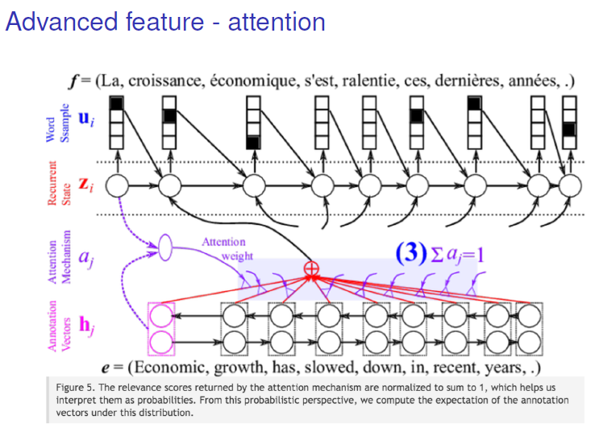It would be possible that there were some **specific postal stamps in the sequence** somewhere in the middle. We can make a model that shortcuts this type of message running alone on the sequence and pays attention to a specific part of the sequence. This is done with **attention**.

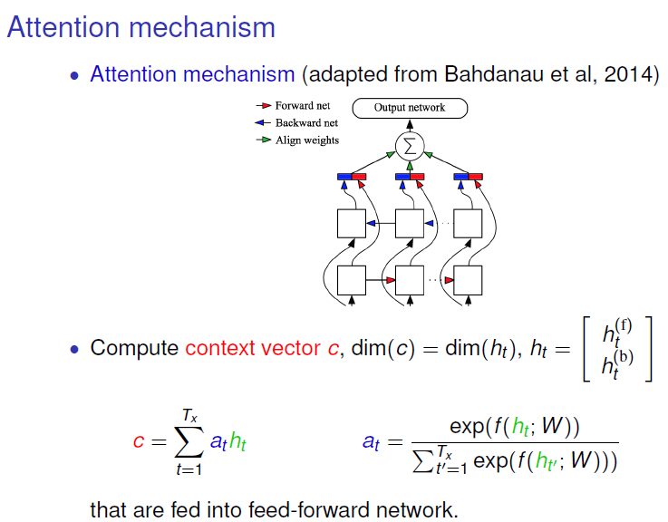The basic idea is that we use all the hidden states, doing bidirectional models **concatenating with hidden state**s from different time instants. And then the **attention model** works as a small NN that takes as an input the concatenated hidden states compared and compares it with learn representation and if there is a match it will pay attention there.

This is **implemented with a SoftMax function**. It takes the hidden states, and weights learned from the attention model, and if there is a good match f function will be large and will pay more attention.

What we pass forward in our FF classifier is **not any hidden state**, is a **weighted combination of all of them.**

* **4. Quasi RNN:**

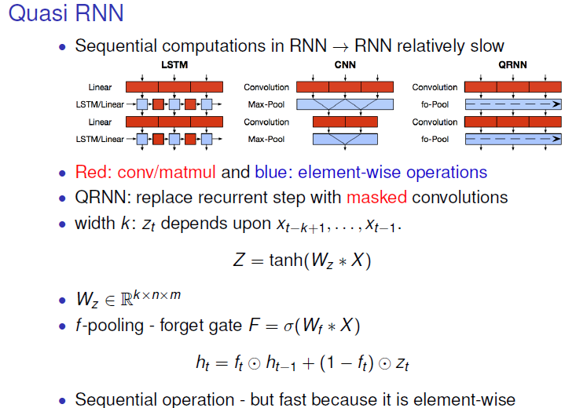The idea is that we will use convolution and pooling in place of recurrent connection. This is a way to speed up the part of the model evaluation that is based on RNN.

The problem is that there is a lot of calculation in RNN that is sequential.

Red lines show matrix multiplications through a sequence what is slow.

In QRNN will replace the recurrent computation by element-wise operations with parallel computations. Instead of normal convolution, it will be a masked convolution such that we can send information forward in time.

The first step in QRNN Z is computed with the input sequence x and a weight matrix (width filter x size of the internal representation x length “x” for one time unit) to convolve with tanh.

Then to produce hidden state we perform a sequential operation “forget gate” F (sigmoid). Circle with dot in means elementwise. Depending on the value of f, will copy hidden state from the previous time step or just update the new one.

The sequential here is elementwise so is faster than RNN in which sequential operations are matrix ones.

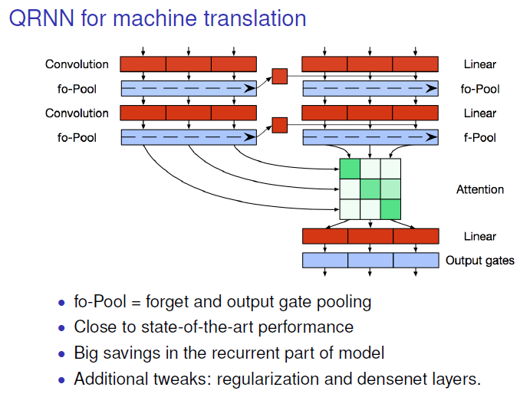Encoder: in the left

Decoder: in the right

These are connected to the output through an attention function and find shortcut connections between both inputs.

* **5. Non-recurrent sequence to sequence models:**

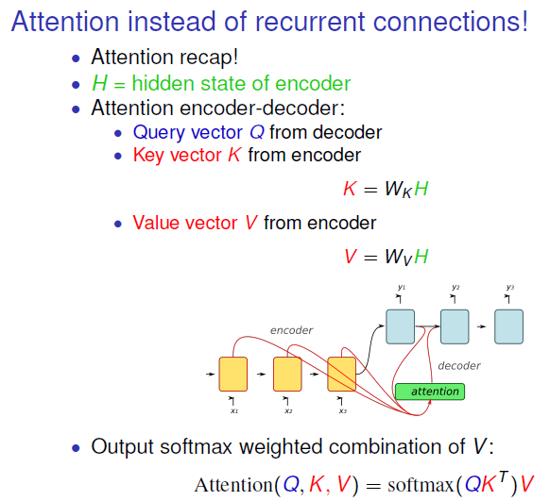The idea is that we have an encoder (sequence), for example one hidden state for each time step of the sequence and the attention model has 3 elements:

**Query vector**: comes **from the decode**r. Is derived from the hidden state **in time t** to say **what should be the output.**

**Key vector**: H comes **from the encoder**, from the m hidden states. And then is weighted by a linear function.

**Value vector**: Calculated in the same way.

**Attention** function is same size as Value vector. It is **computed as the SoftMax** between the Query vector, what we want to decode in next step, and then the Key vector, the context from the encoder. Calculated for each position of the sequence with m outputs, and then we use these values as a weight for the Value vector.

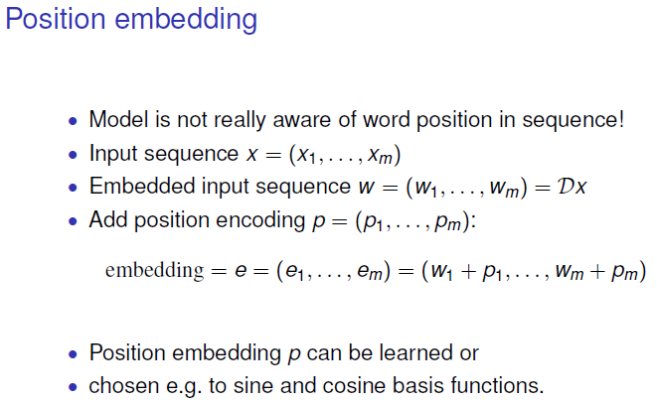

If the model doesn’t care the order of the model it is solved by position embedding.

We embed input sequence into some other or same dimensional space by multiplying it by an embedding matrix. Now we come with a new embedding p that has the same

dimensionality that w and we can add it to the input embedding e.

This p vector is the same for all examples, so it gives information about the position in the sequence.

**Week 6 - Tricks of the trade and data science challenge:**

* **1. Faster convergence**

**INITIALIZATION:**

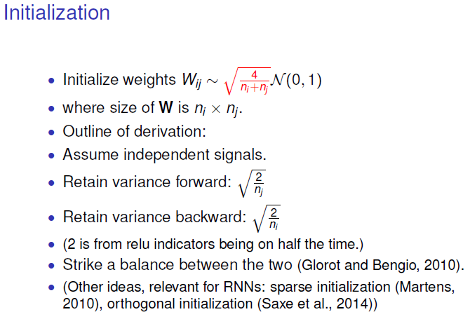**Initialize weights** by a random number multiplied by this square root.

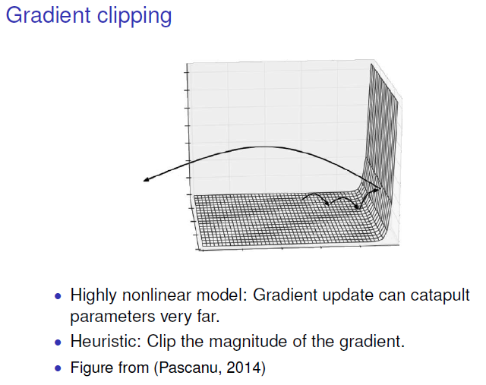**Gradient clipping**: The idea is that we have this energy landscape which is quite flat and then at some point we meet the wall and if we take our small gradient descent at some point, we might end up a point in which gradient is very large to some completely different weights. To avoid it, we **truncate the values of the gradient**.

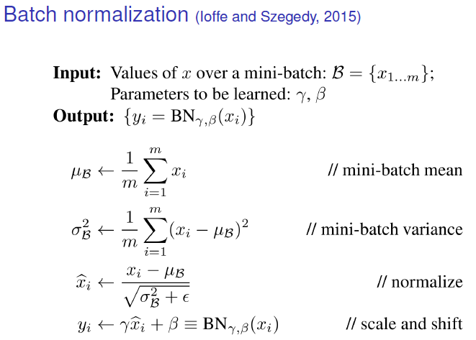Calculating the mean and the variance we normalize the input to each hidden unit.

We can scale the inputs as parameters.

* **2. Better performance regularization:**

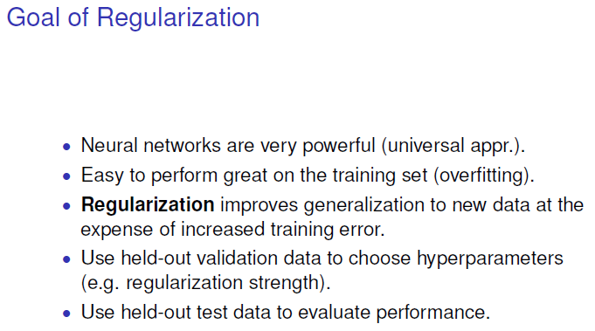

**Regularization methods:**

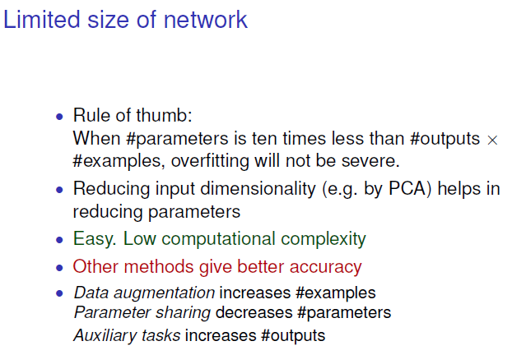**Reduce input dimensionality**: By PCA (Principal Component Analysis) looking those directions in the input space which have the highest variance and we project data in these directions.

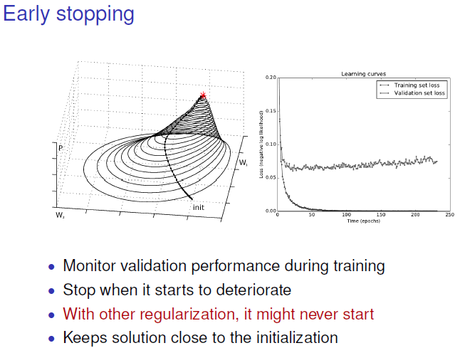**Early stopping**: Training error goes down, but validation reach minimum at 25-30 iterations, and we can stop there. But we can also run the model until the end and get best solution.

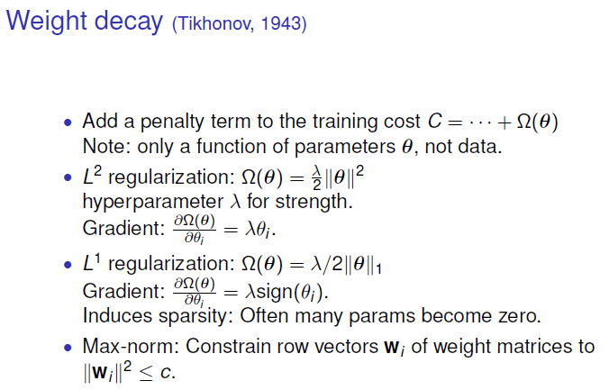Weight decay: We add another term to the cost function.

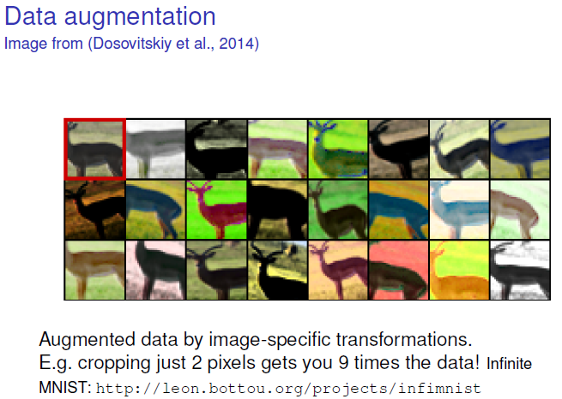Generate amount of extra data.

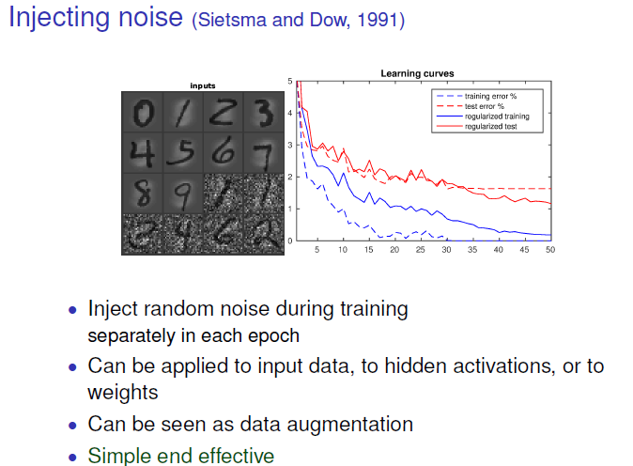We can inject noise at different levels:

At the input of the data.

Inside the hidden units, so they become stochastic, avoiding the network being adapted to very specific features.

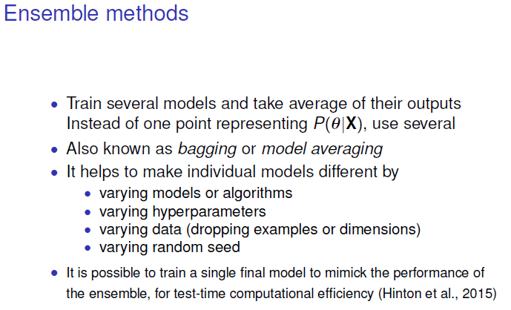

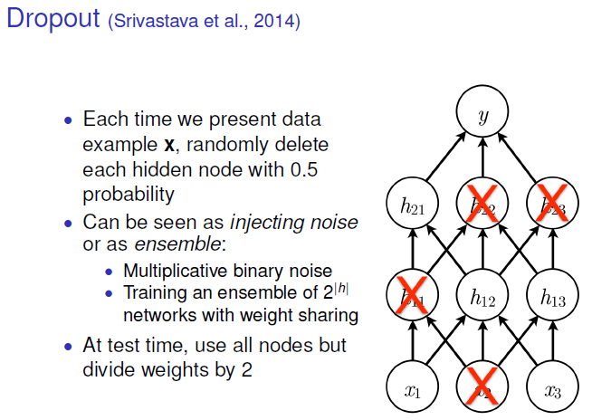Dropout: The idea is that we remove hidden units at random. We must decide how many hidden units to remove (a good number is between 20-50%).

At test time, if we have trained with 50%, divide weights by 2.

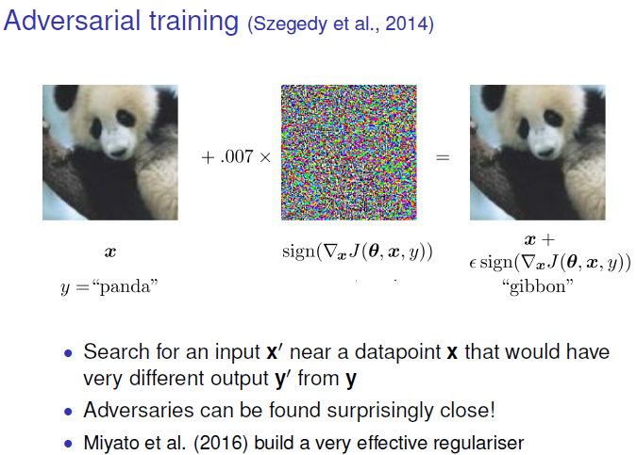Taking x of the panda input and looking the cost function, we can change the image on the direction in which the cost function increases the most. In this way, network is confused. That’s a good way to make a robust network.

It doesn’t work in every dataset.

**RECIPE TO TRAINING NN**

* **1. Not knowing your data is a recipe of failure:**

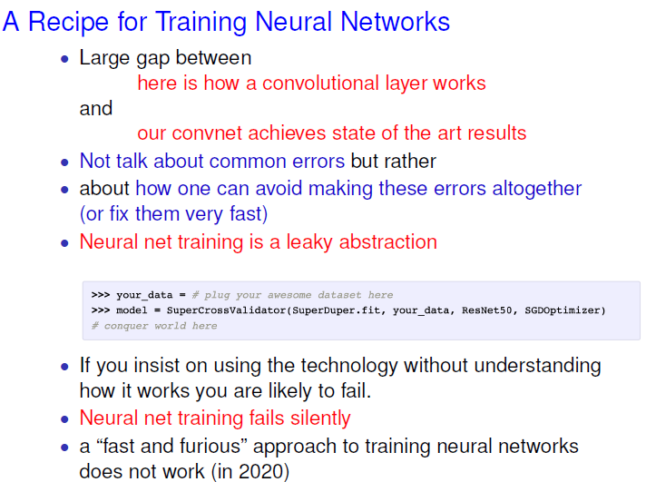 Cdv

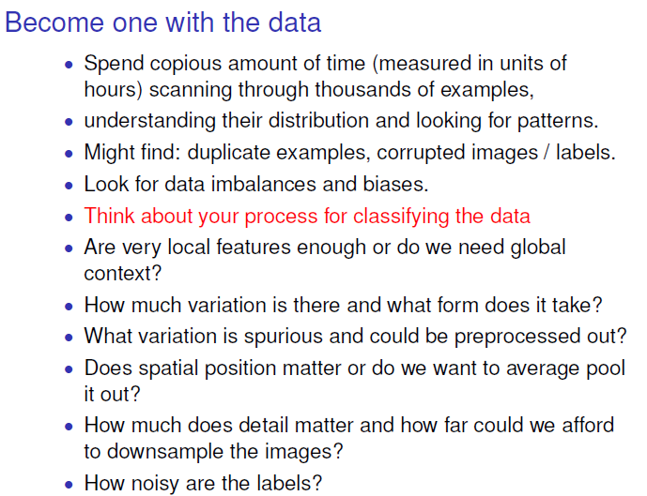

* **2. Simple baselines:**

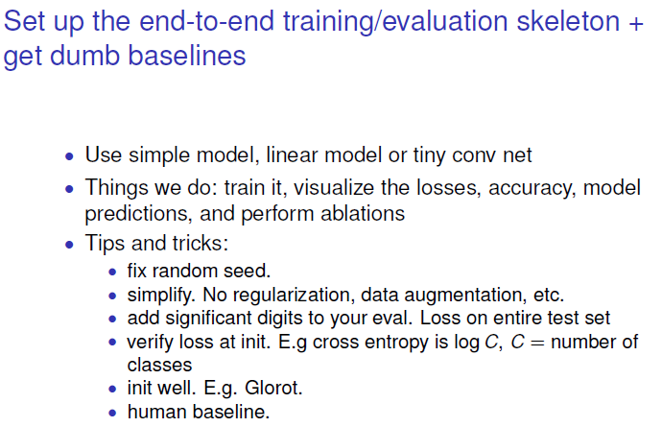Start building simple models (small CNN).

Once we have trained setup the model, build training loop, visualize loss, …

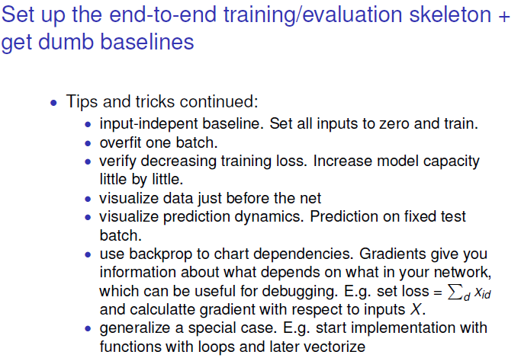

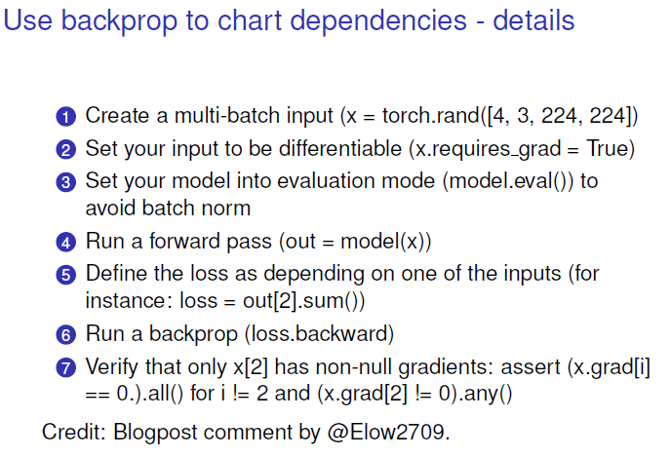Make sure that there is not kind of leakage of information between different examples in your mini batch.

To check if the backwards is applied correctly for each of the inputs.

* **3. Overfit, regularize and tune in that order:**

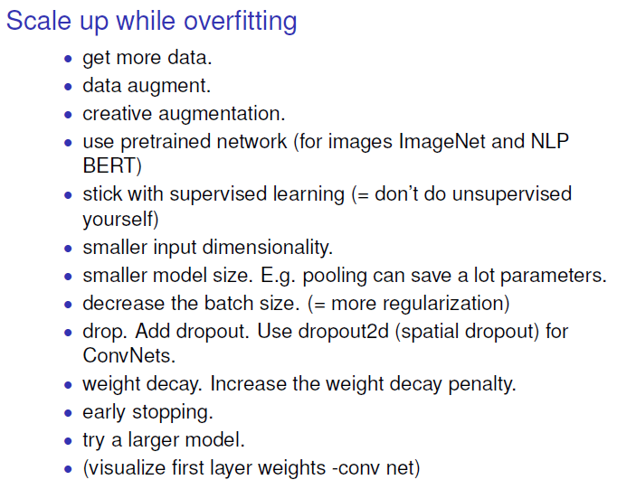

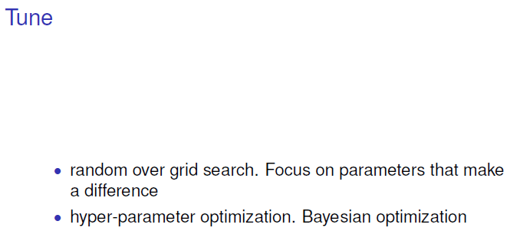

**Week 7: Un- and semi- supervised learning**

* **1. Unsupervised learning:**

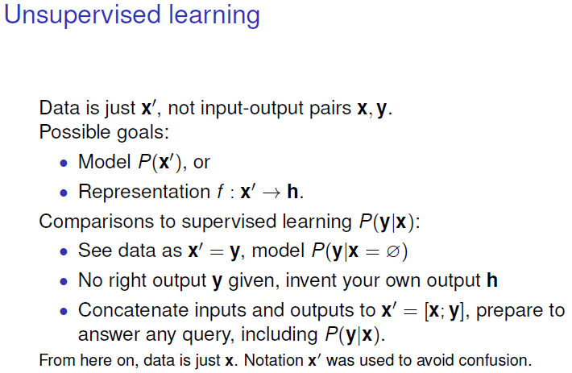Now we have only x as input and what we want to learn is a density model of the data.

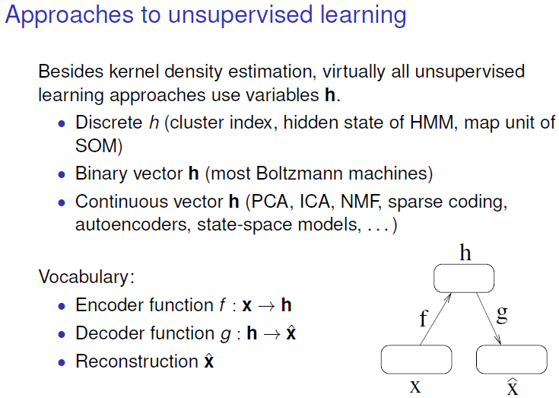

Almost all approaches of unsupervised learning use a set of latent variables (h in this slide, C in the next slides).

We have a model, a so-called autoencoder, which takes our data X and through a function f maps that to this latent space, and then we have a mapping from the latent space through a function G back to the original image space. This can be called reconstruction.

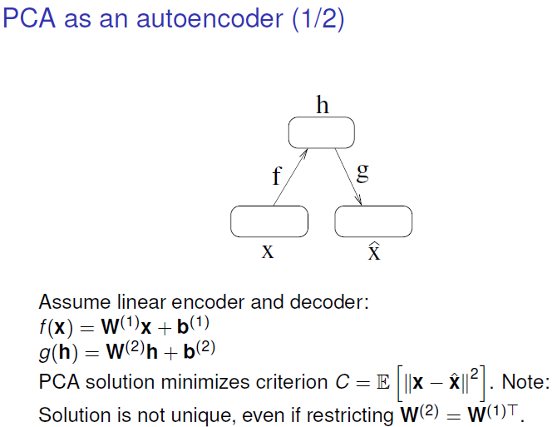

PCA handles two linear mappings (f and g). W1 weights matrix that maps from the input space to the latent space. And then we have W2 matrix to map between latent space and original space.

PCA chooses some dimension of the latent space, for example 2, and minimizes the difference between the original data and the reconstruction. The solution is not unique, even if we restrict the Ws to be each other transpose.

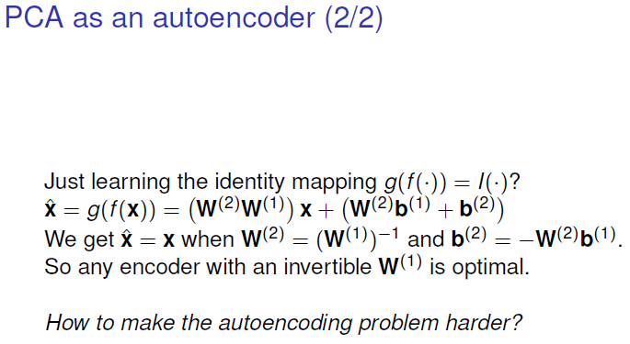

* **2. Auto-encoders:**

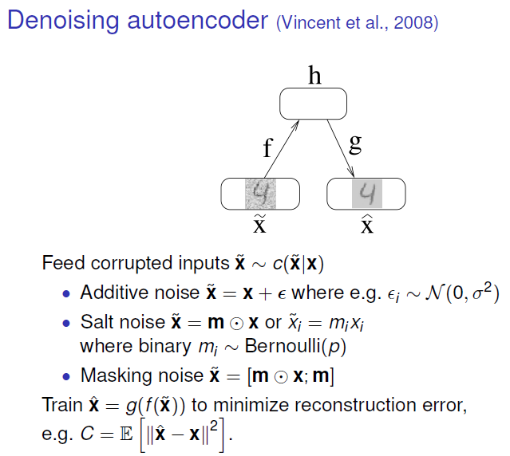In order to avoid the identity we could for example corrupt the original image so we can add noise where we have a mask “m” multiplied element-wise on the input a binary map so we remove pixels and now we can learn this mapping where we try to make the reconstruction error smaller.

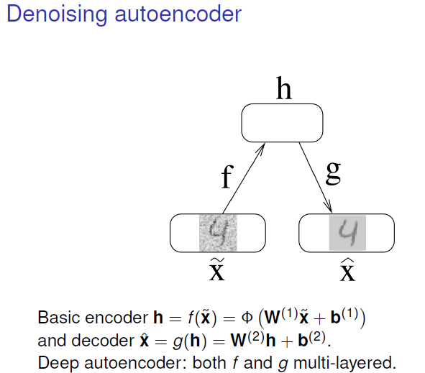Instead of having a linear model as we have before, we can apply a non-linear model.

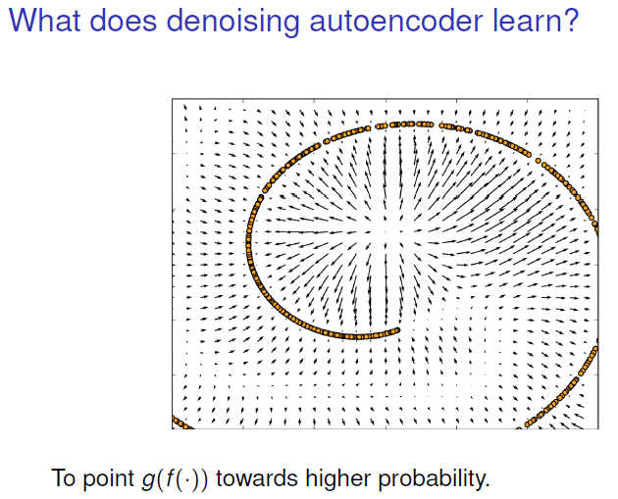

Our truth data is lying in some manifold in this 2d space. Adding noise we remove points away from the manifold, and now what the auto-encoder will learn, because it must reconstruct the uncorrupted image, is to take a point that lies outside the spiral and move it closer. That means the auto-encoder will try to put things back on the data manifold. In that way, it has learned a lot about what manifold the data lies on.

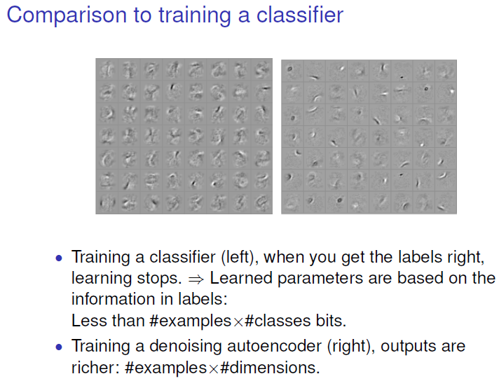

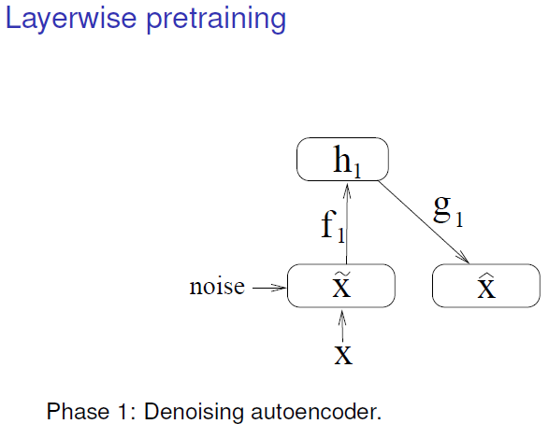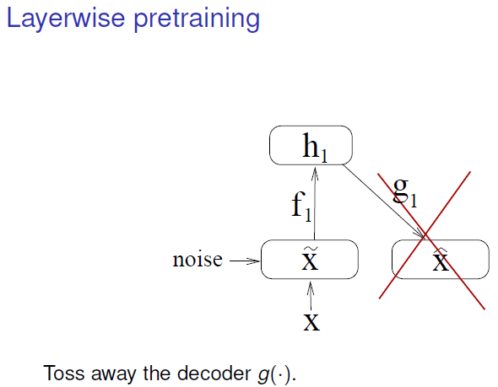

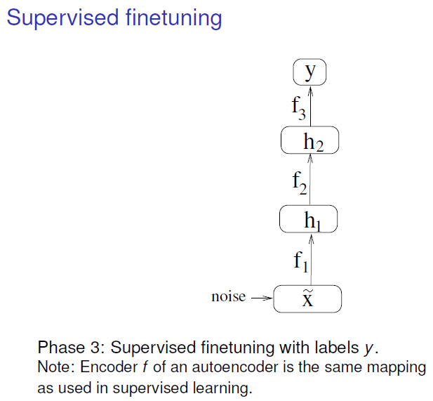

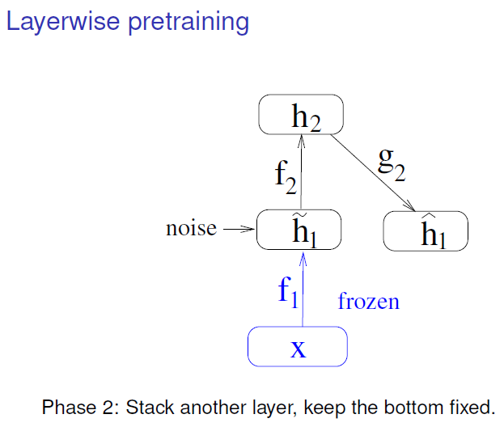

1. Considering a denoising autoencoder as before, it is going to learn f1 and g1 mapping.
2. In the next step we forget about g and take our hidden representation h1 and add new noise to that and then we train another denoising autoencoder to reconstruct the uncorrupted version of the latent variables h1.
3. We can do 2) several times and now we have learned 2 hidden representations of the original data

* **3. Deep generative models for un- and semi- supervised learning:**

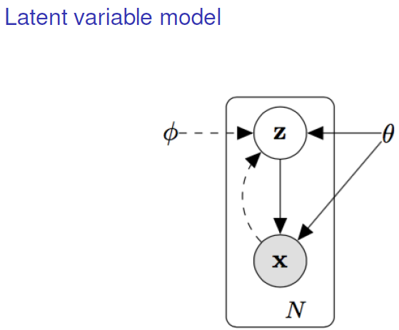Now, instead of having h to represent latent variables, we have Z, and x for the observations. The box outside indicates that we have n unlabelled data points.

The arrow going down is the decoder and the dashed line going upwards is the decoder. In the probabilistic framework, both of these mappings are conditional probability distributions.

Phi and theta are the parameters we use in the decoder and in the encoder.

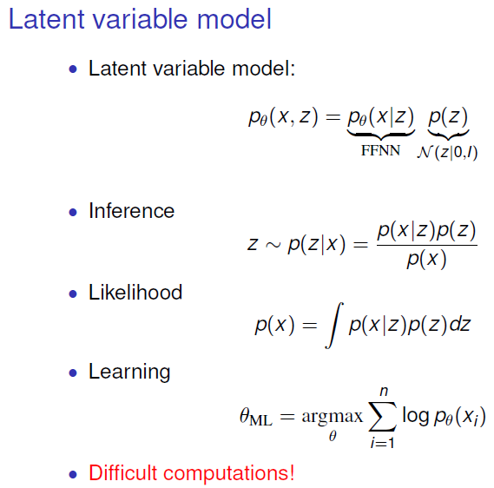We want to make all paths of the model probabilistic.

In our so-called generative model, we have the joint distribution of our X’s (observations) and our latent variables, and we decompose that in terms of a simple distribution on our latent manifold PFC (a normal distribution with no covariance between different components of our latent variables).

